Appendix B: Target Solution Architecture
This appendix describes the characteristics of the logical architecture and the prerequisites for the technical architecture of the involved applications. The logical architecture is the representation of the data models of the involved application(s), including the interfaces. The technical application architecture prerequisites describe the minimum infrastructure components and configurations to ensure performance of the supported applications and/or application platforms. Such minimum components and configurations can refer to processor, memory, storage, protocol and connectivity requirements. Such requirements would also apply to cloud-based application platforms. The logical and technical architectures can be owned and maintained by the DHHS, owned by the DHHS and maintained by the vendor, or owned and maintained by the vendor.
For all services where DHHS requires the vendor to develop and maintain applications on DHHS-owned infrastructure, the architecture should also include the technical infrastructure architecture. Since iServe Nebraska Portal will be deployed in a public cloud, the logical and application technical architecture characteristics will suffice.

iServe Nebraska Initiative Overview
The following figure below provides an overview of the overall iServe Nebraska initiative, including key goals and objectives, as well the required business and technical capabilities.
- iServe Nebraska Initiative Overview
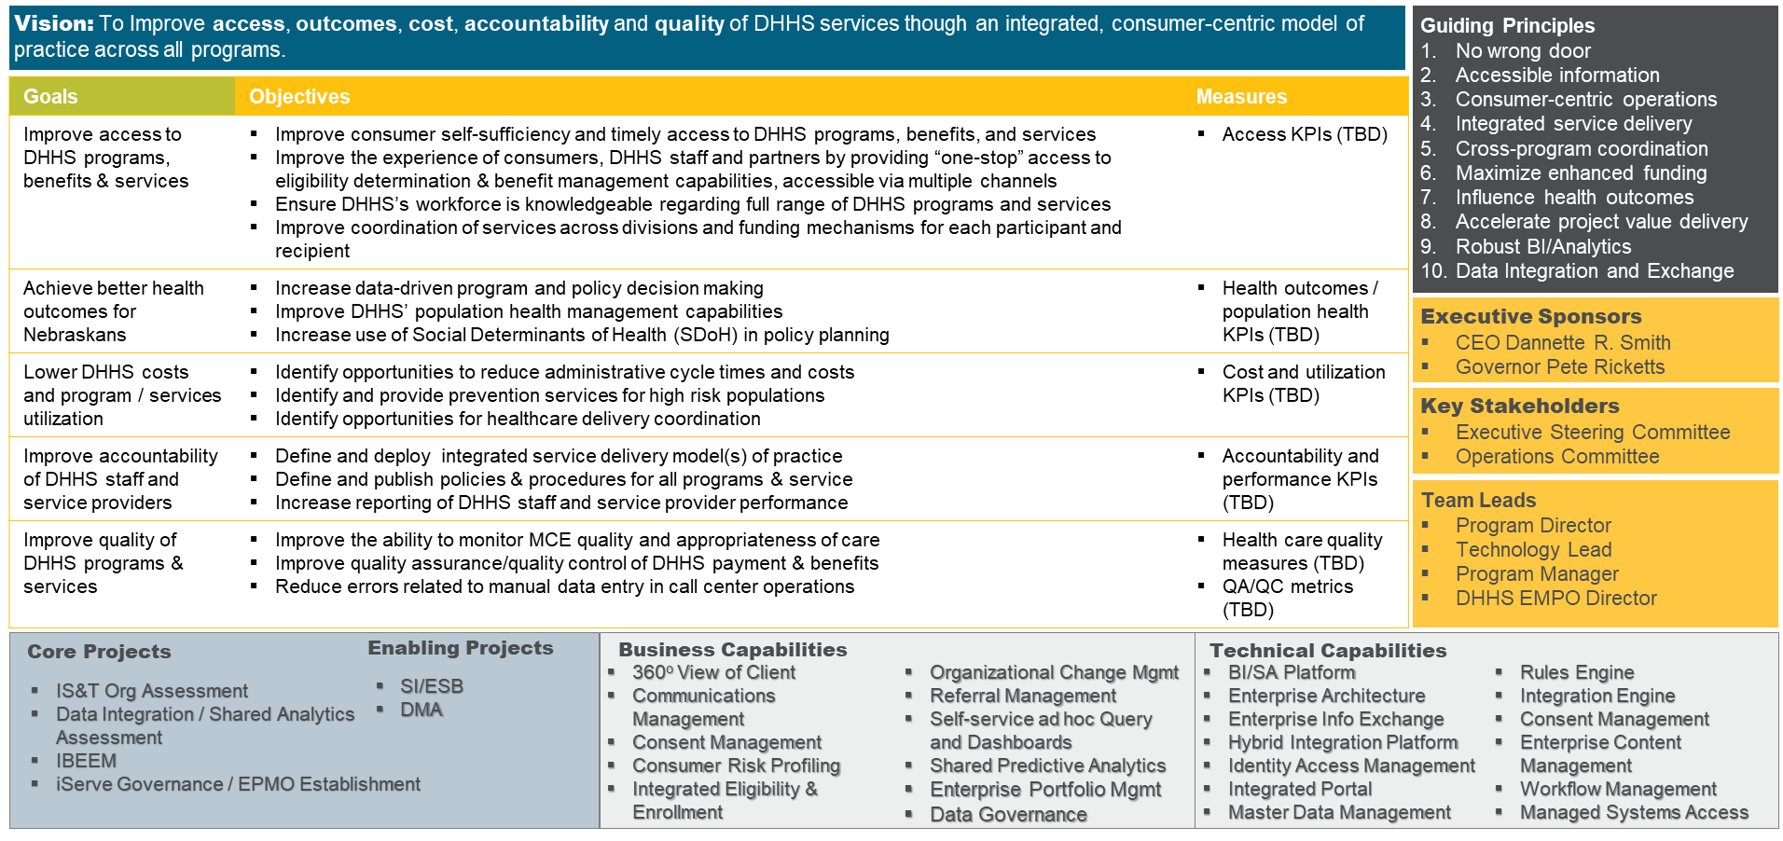

Enterprise Solution Architecture Guiding Principles
The iServe Nebraska Platform and DHHS Enterprise Architecture are built based on the following key guiding principles:
- Low Maintenance – The iServe Nebraska Platform and Portal Target Solution Architecture will enable and emphasize ease of maintenance and flexibility to respond to ongoing changes by adhering to principles of modularity, loose coupling, abstraction and reusability.
- Architectural Resilience – The Target Solution Architecture will be able to evolve with changes in the information technology industry best practices and ensure that the solution will not encounter any architectural dead ends.
- Integrate Effectively with Existing DHHS Solution Architectures and Systems – The Target Enterprise Solution Architecture will be able to easily take advantage of existing DHHS information technology investments and allow for integration with existing solutions.
- Optimal User Experience – The Target Enterprise Solution Architecture will be able to create intuitive, user friendly UI/UX design using best practices across industries and allow for future innovations.
- Continuous modernization and incremental replacement – The N-FOCUS Eligibility System will be incrementally replaced by foundational iServe Nebraska Platform, to support IBEEM functionality, by identifying the high priority business capabilities that need to be modernized and enhanced to better serve Nebraskans using modern, cloud-based technologies that can be cost-effectively supported
- Do no harm – Incremental replacement of high-risk business capabilities and legacy technologies will NOT reduce the level of current automation / operational efficiencies or have a negative impact on current business performance or outcomes
- Modularity – The iServe Nebraska Platform will move the solution architecture towards discrete scalable, reusable modules that make rigorous use of well-defined modular interfaces and use industry standards for interfaces. This includes wrapping the legacy functionality in NFOCUS to enable seamless access from the new iServe Nebraska Platform technology components
- Continuous Integration – The iServe Nebraska Platform will adopt a DevOps culture with a focus on implementing and maturing Continuous Integration and fully automated testing practices
- Vendor dependency and lock-in – The iServe Nebraska Platform Solution Architecture and sourcing approach will seek to reduce the state’s dependence on any single technology or service provider, and will maximize portability and minimize vendor or technology lock-in
- Cloud migration – The iServe Nebraska Platform solution will prioritize migration of all environments, including Production, to a hybrid (Private and Public) and native cloud architecture over time to leverage the available on-demand capacity, flexibility, efficiencies, and cost advantages
- Responsive to change – The iServe Nebraska Platform will adopt effective product management practices and disciplines that leverage scaled agile principles to ensure frequent and incremental deployment of the most valuable business capabilities into the production environment
- Representative governance – The iServe Nebraska Platform Governance model will ensure proper and effective representation by business and technical leaders from across all DHHS Divisions and Programs that are affected by changes to the systems that make up iServe Nebraska Platform.
- Enterprise-level prioritization – The iServe Nebraska Platform’s requirements will be prioritized at the DHHS enterprise level with thorough research and evaluation of the intended benefits and impact on the target Nebraskan beneficiaries and consumers
- Secure and manageable – The target architecture for the future iServe Nebraska Platform solution will continue to be protected against the common Internet threats and will be manageable within the existing operational and financial constraints

Target Software Design Architecture
DHHS leadership would prefer to leverage the Service Based Architecture pattern to leverage contemporary best practices in delivering a flexible and responsive solution to the end users as depicted in the Figure below. Continuously evolving business demands, and user expectations require an architecture that supports agility, flexibility and innovation. A Services Architecture provides the fundamental architectural capabilities that enable applications to support multiple experiences and respond rapidly to digital business demands. It provides an evolutionary approach that enables DHHS software development teams to iteratively modernize and incrementally replace the hard to maintain application modules in direct response to business priorities.
- Traditional Three-Tier Application Architecture vs. the Service Based Architecture Model
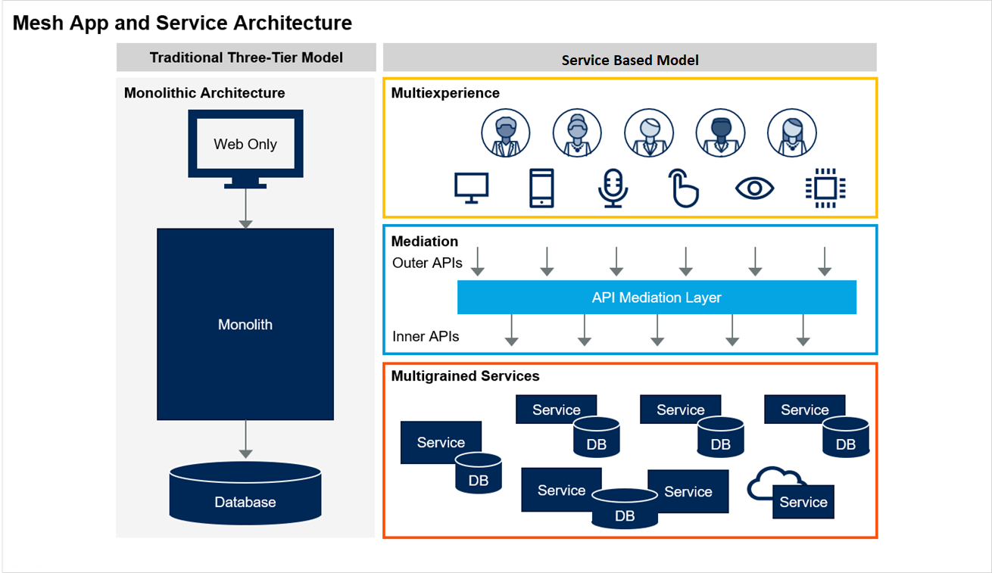

A critical principle in Service Based Architecture is ensuring that the individual parts of the application can change as needed without impacting other parts of the application. Because APIs can cause tight bindings between application components, all API interactions are abstracted to ensure loose coupling and flexibility. An API mediation layer addresses these and other concerns. The mediation layer allows a service to expose an “inner API” that directly reflects its domain model, and one or more “outer APIs” that are tailored to support IBEEM requirements. The API mediation layer intercepts communications between two application components (app-to-service or service-to-service) and enforces policies that apply to the communication. DHHS plans to use a business-centric approach to assess the modernization opportunities that have the highest opportunities to manifest “business value” as rapidly and as frequently as possible, using the anticipated frugal and constrained budgets post COVID-19.
The RFQ respondents are able to propose alternative design pattern and approaches that they have successfully used with other clients, however, they should clearly document the rationale for their approach as well as anticipated benefits to Nebraska DHHS and Nebraskans.
- Building a Service Based Application in an Agile Fashion
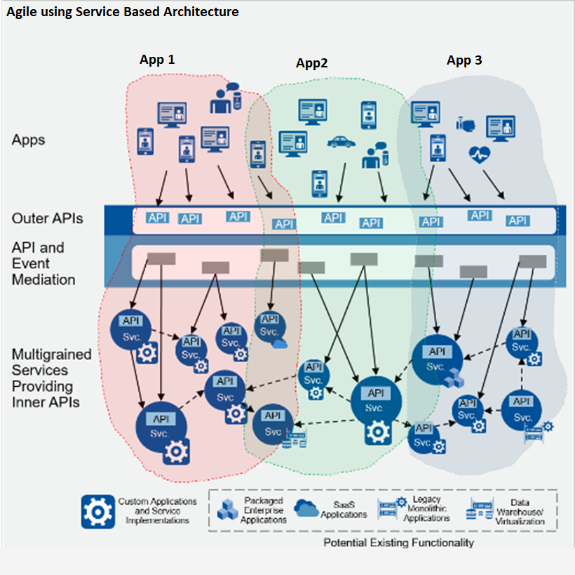

Target Platform Architecture Shared Technology Components
iServe Nebraska Portal and Platform will be built on best-of-breed technology components and capabilities that can be leveraged to deliver the full vision of integrated health and human services delivery for iServe Nebraska, as per the figure below.
- iServe Nebraska Platform Future Solution Architecture Components and iServe Nebraska Portal Scope
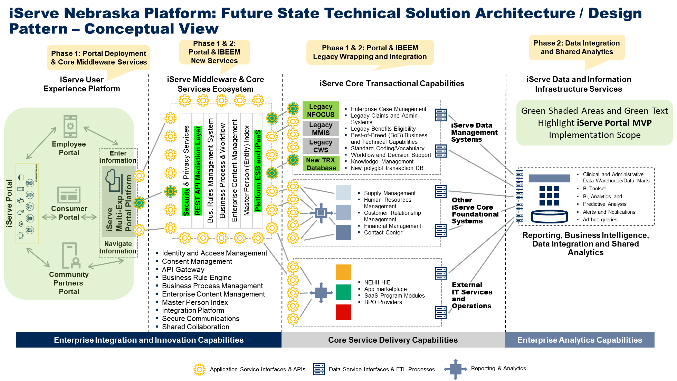
User Experience Tier
Nebraska DHHS has selected the Microsoft Multiexperience Development Platform (MXDP) made up of a number of key Microsoft offerings such as Microsoft Azure LogicApps, PowerApps as well as the Dynamics 365 Customer Engagement platform. A multiexperience development platform is expected to provide the development teams an opinionated and integrated set of front-end development tools and “backends for frontends” (BFF) services. Its purpose is to enable distributed and scalable development (both in teams and architecture) of fit-for-purpose apps across digital touchpoints and interaction modalities.
It is expected that adopting an MXDP helps to bring together development activities across myriad types of apps so that the user experience across them is seamless and more engaging. The platform is not merely a loose collection of tools and services, but rather an opinionated development platform stack — meaning there is guidance and certain prescribed approaches to development for teams to ensure consistency and productivity.
An MXDP is intended to provide the design-time and runtime platform to better standardize and accelerate the development of these fit-for-purpose apps for Nebraskans, community partners, and for DHHS employees. By adopting an MXDP, DHHS expects to:
- Improve collaboration with the business in designing, building, and managing apps and experiences, particularly as part of a continuous modernization strategy.
- Accelerate app delivery by increasing developer productivity across multiple digital products using high-productivity tooling, shared components and services, and common development languages and patterns.
- Support better application architecture, with mediated APIs and a BFF design pattern, to simplify application maintenance across touchpoint and modalities.
- Reduce the total cost and time of development by providing BFF APIs and services that are portable and reusable across touchpoints, such as offline data synchronization, push notifications, location services, natural language processing, state retention and user session management.
- Enable faster release cycles and continuous improvement by utilizing DevOps practices and tooling supported within the platform.
Using the Service Based Architecture, it is expected that DHHS will not have to just pick a single approach for building custom app experiences. Using multiple approaches provides additional flexibility in technologies and design, but multiple options require multiple skill sets and implementation models, as well as a wider scope of support and maintenance. Since DHHS technology skill sets in this domain are limited, it plans to use the approach that best fits the overall UX requirements of iServe NE Portal MVP and provides the highest level of developer productivity without sacrificing the required modularity. It is anticipated that the Microsoft Multiexperience development platform will provide the opportunity for relatively higher levels of developer productivity as well as the benefit of common information models.

Figure 5. Maximizing Developer Productivity and Optimizing User Experience
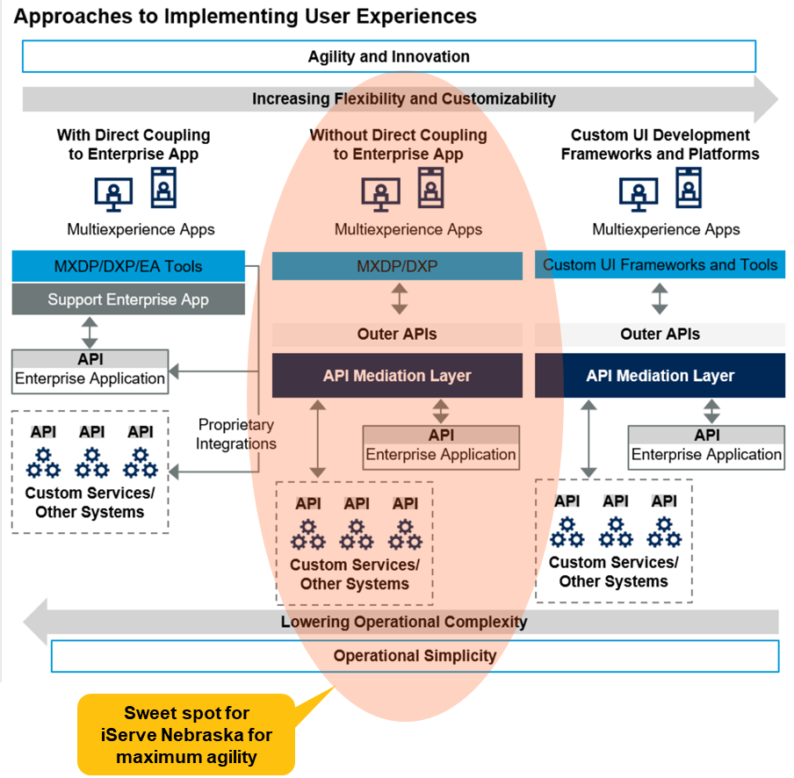

While the Microsoft MXDP platform has been selected as the preferred User Experience target development environment, DHHS technical leadership is concerned with the level of granular controls, functionality and performance of the Microsoft MDXPs in designing optimal and rich user experiences and therefore would like to leave open the possibility for use of custom User Interface frameworks and tools as augmentation or replacement tool(s) for the development of effective user experiences. The alternative to an MXDP is to assemble specialized development tools to meet all the use cases and developer personas’ needs. The Vendor respondents must also be able to define a reference architecture based on proven patterns and demonstrate how they will adhere to it. The respondents are encouraged to offer alternative front-end development tools and approaches along with the rationale for the proposed approach using tool such as:
- Native iOS and Android development.
- Progressive web app development.
- Bot frameworks and conversational platforms (such as Google Dialogflow and Amazon Lex).
- Augmented reality toolkits (such as Wikitude, 8th Wall and Letsee).
- Open-source and cross-platform frameworks (such as React Native, Flutter and Ionic).
- The back-end stack required to support such a best-of-breed approach may consist of:
- Various PaaS services (such as communications PaaS [Twilio], database PaaS [MongoDB]).
- API gateway and management products.
- Cloud-hosted AI services.
Legacy Modernization Through Modularization and Refactoring
DHHS IS&T leadership expects the vendor(s) to work from top down to modernize the existing benefits eligibility and enrollment solution, N-FCOUS:
- Expose APIs – Begin the process by iterating the APIs until there are stable, well-liked versions.
- Modularize code – Modularize the code within existing monoliths helps to identify and understand domains. Use the APIs that have been created as one of the inputs to that modularization.
- Change and scale of deployment – Once the modularity reaches the point where it’s stable and makes sense, change the deployment model from a monolithic model to a set of separate, coarse-grained services.
- Separate data – The last layer to change involves database services. The vendor(s) to assess whether refactoring the applications’ original database architecture into logical database instances makes sense — especially if that architecture is large, monolithic and complex.
The key focus areas and expectations of the vendor(s) include:
- Refactoring high-value monolithic applications for modularity and maintainability – But not decomposing them into more discrete components or services than are necessary to achieve explicit agility goals tied to business outcomes. The valuable application logic in the monoliths need to be exposed and utilized.
- Applying microservices principles pragmatically after adopting agile development and basic DevOps practices – Micro-services architecture alone will not create agility; the Vendor must address application delivery practices and platforms as well. Not all of the code the vendor writes and supports need to be deployed daily or even weekly. The Vendor must avoid overcompensating for the intransigence of the legacy applications by arbitrarily exploding them into microservices. The services should be as small as they need to be to meet DHHS agility goals, but no smaller.
- Adopting an API-first strategy, and building the integration capabilities needed to govern, create and compose those APIs – With the diversity of endpoints increasing inside and outside DHHS, an API-first mindset is expected to provide the flexibility to support them.
- Planning for delivery, operation and governance of applications in a multicloud environment, and selecting key platform tools that support this – Even the most stringent “one cloud” strategy can be undermined by an acquisition or differentiating business-critical capabilities emerging in other providers’ cloud platforms. The vendor(s) must identify the most valuable modes of multicloud delivery for DHHS and avoid overcomplicating the approach.
- Being Competent with Core Web technologies and decoupling code as much as possible from frameworks – HTML, CSS and JavaScript should all be core competencies for the web developers.
- Building modular client applications that foster flexibility and agility in both design and delivery – DHHS expects a modular approach to web app development to allow the design and implementation of the app one piece at a time to support the iteration needed by agile practices.
- Reusing components as much as possible, and not reinventing the wheel - With the availability of high-quality component and widget libraries built atop high-quality JavaScript frameworks, vendor developers should not write their own components from scratch for the in-scope applications.
The iServe Nebraska Platform and the iServe Nebraska Portal MVP will be built using an enterprise agile methodology. DHHS IS&T (Information Systems and Technology) organization has selected the Scaled Agile Framework (SAFe) methodology to incrementally build and deliver the modernized solution. DHHS leadership anticipate a minimum of two or three dedicated development teams focused on the Platform (configuration and build out of the core cloud platform and securely connecting it to the State of NE data centers), Product (developing the new business and user capabilities, features, and stories), and Legacy Modernization (analyzing and converting the existing legacy functionality into rightsized modular services that can be called via Representational State Transfer (REST) APIs from the target cloud architecture components). These teams will collaborate to plan the SAFe Program/Solution Increment (PSI) based on prioritization defined by the business sponsor and the Product Manager. The scope of iServe Nebraska Portal MVP is described in the requirements document attachment to this document (Appendix H).

