State of Nebraska Department of Health and Human Services

iServe Nebraska Portal Requirements

24 August 2020

Table of Contents

1.0 Introduction 1

1.1 Background 1

1.2 iServe Nebraska Program Overview 1

1.3 Document Purpose 5

2.0 Approach and Methodology 7

3.0 iServe Nebraska Business Capabilities Model 10

3.1 Overview 10

3.2 DHHS Business Capabilities (Level 0) 11

3.3 iServe Nebraska Business Capabilities (Level 1) 11

3.4 Integrated Benefits Eligibility and Enrollment Management (IBEEM) Business Capabilities (Level 2) 11

4.0 iServe Nebraska Portal Stakeholder Analysis 12

4.1 Consumer Stakeholders 12

4.1.1 Applicants/Clients 12

4.1.2 Parent or Legal Guardian / Authorized Representative 13

4.1.3 Key Needs, Pain Points and Opportunities for Improvement 14

4.2 DHHS Staff 14

4.2.1 Create ad hoc queries & reports Key Needs, Pain Points and Opportunities for Improvement 16

4.3 Community Partners & Providers 16

4.3.1 Key Needs, Pain Points and Opportunities for Improvement 17

5.0 iServe Nebraska Portal MVP & IBEEM Scope 18

6.0 iServe Nebraska Portal MVP Process Flows 21

6.1 Overview 21

6.2 Workflow Notations 21

6.3 Access / Intake 23

6.3.1 Process Flow 1 (PF1): Integrated Eligibility Pre-Screening 23

6.3.2 Process Flow 2 (PF2): Submit IE Application via iServe Nebraska Portal 24

6.4 Client Self-Service 27

6.4.1 Process Flow 3 (PF3): Create iServe Nebraska Account 27

6.4.2 Process Flow 4 (PF4): Log in / Log out of iServe Nebraska Portal 28

6.4.3 Process Flow 5 (PF5): Send / Receive secure message 29

6.4.4 Process Flow 6 (PF6): Upload files 29

7.0 iServe Nebraska Portal MVP Use Cases 31

7.1 Overview 31

7.2 Access/Intake 32

7.2.1 Use Case 1 (UC1): Integrated Eligibility Pre-Screening 32

7.2.2 Use Case 2 (UC2): Submit IE Application via Portal 35

7.3 Client Self-Service 39

7.3.1 Use Case 3 (UC3): Create iServe Nebraska Account 39

7.3.2 Use Case 4 (UC4): Log in / Log out of iServe Nebraska Portal 41

7.3.3 Use Case 5 (UC5): Send / Receive Secure Messages 43

7.3.4 Use Case 6 (UC6): Upload Files 44

8.0 iServe Nebraska Portal MVP Requirements Candidates 46

8.1 Business/User (Functional) Requirements 46

8.1.1 Business/User Capabilities 46

8.1.2 Business/User Features 46

8.2 Enabling (Technical) Requirements 50

8.2.1 Enabling Capabilities – Multiexperience Portal 50

8.2.2 Enabling Capabilities – Identity and Access Management 52

8.2.3 Enabling Capabilities – API Mediation 53

8.3 Non-Functional Requirements 53

8.3.1 Security & Regulatory Compliance 53

8.3.2 Performance and Availability 56

8.3.3 Scalability and Extensibility 56

8.3.4 Audit and Reporting 57

8.3.5 Usability 58

1. Introduction
   1. Background

The State of Nebraska Department of Health and Human Services (HHS) is the State’s lead agency in helping people live better lives. DHHS is responsible for administering numerous services throughout Nebraska, including Medicaid and Long-Term Care, Developmental Disabilities, Public Health, Behavioral Health and Children and Family Services.

DHHS has embarked on the iServe Nebraska Program to improve access, outcomes, cost, accountability and quality of DHHS services through an integrated, consumer-centric model of practice across all programs. This transformation will be enabled by the implementation of an iServe Nebraska Platform to support Integrated Benefits Eligibility and Enrollment Management (IBEEM) functionality.

The iServe Nebraska Portal project is both a foundational technology component of the iServe Nebraska Platform, as well as the implementation services needed to deliver a minimum set of highly valuable functionality to DHHS consumers referred to as the MVP (Minimum Viable Product) throughout this document.

The State plans to procure the technology and key subject matter expertise needed to implement the iServe Nebraska Portal to deliver the minimum viable product (MVP) capabilities by April 2022, as a foundational component of the IBEEM functionality, specifically to support the submission of an integrated eligibility application for DHHS’ Medicaid and Economic Assistance programs.

* 1. iServe Nebraska Program Overview

Nebraska DHHS is moving from a program-centric approach focused on discrete outputs to a person-centric approach focused on delivering services to achieve the desired outcomes. Achieving the vision will mean adopting a different way of approaching DHHS’ model of practice, modifying policies that constrain the ability to share data, and introducing a new way to think about information and technology, as well as other changes.

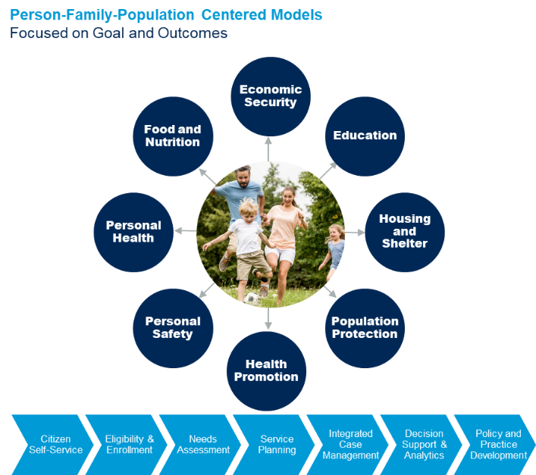DHHS has established a clear vision for the IBEEM solution. This includes new approaches to technology and moving from stand-alone silos to shared technology components and services.

*IBEEM Vision Statement is as follows: “Easy-to-use integrated eligibility determination, enrollment, and benefits management; enabled by technology for DHHS consumers, staff, and partners – regardless of where they access it, or on what device.”*

And, more specifically the vision for the iServe Nebraska Portal is the following: “*Through the iServe Nebraska Portal, DHHS will provide Nebraskans with integrated person and family-centered services.”*

This Vision provides Nebraska with key benefits for its stakeholders:

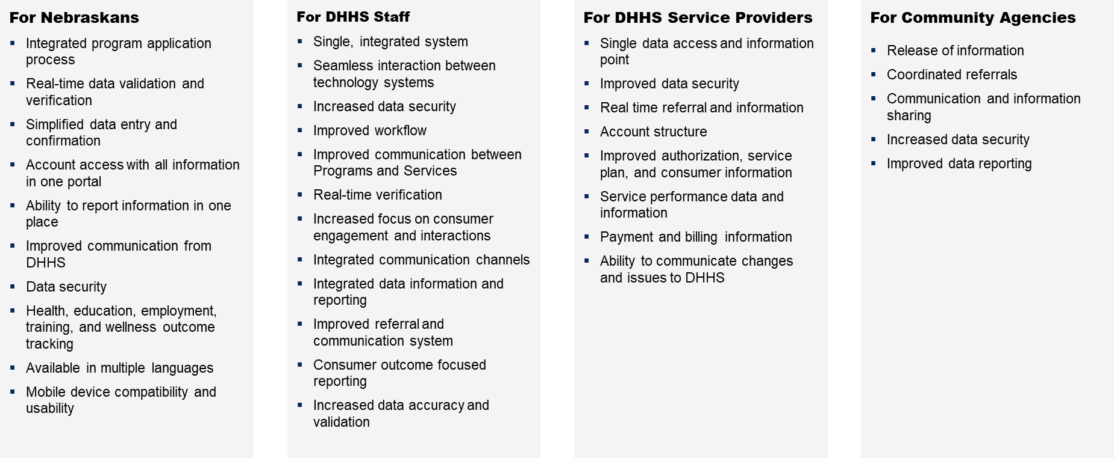

When the future solution is fully implemented the following key capabilities will be in place:

* + 1. IBEEM and Ancillary Functionality
* **Application and Enrollment/Re-determination:** Web-based eligibility determination through an integrated application that supports multiple programs (when possible)
  + - Dynamic, rule-based rule engine that allows updating eligibility rules without significant effort
    - API support for verification of application information with internal and external data sources and systems
    - Automated support for benefits renewal at regular intervals, specified by each program or upon client changes
    - Support for additional activities required after program enrollment such as assignment of a case worker, client signature on required forms or other items
      1. Note: Activities vary by program and some programs require activities such as signature of required forms pre-enrollment; all activities should be conducted as per program rules
* **Intake and Admission:** Collection, verification and processing of additional information needed prior to benefits issuance
* **Interviews/Assessments and Scheduling:** Appointment scheduling for interviews and automated System recommendations on how to proceed with the eligibility determination based upon information collected during an interview
* **Benefits Issuance, Redemption and Management for programs other than Medicaid:** Issuance of the benefits along with the creation and delivery of a welcome package describing pertinent details. Benefits usage tracking and investigation and rectification of potential discrepancies in benefits issued
* **Client Changes**: Management of changes or events affecting a client’s eligibility to receive benefits that may result in immediate suspension, termination of benefits or require the client to go through the re-determination process
* **Client Look-Up and Query:** “White Pages” for Clients (Master Client Index) summarizing a listing of unique Clients and demographic information; identification of program enrollment and current services for Clients as well as a Consent Registry that controls, based upon privacy and confidentiality rules, what information can be shared, when and with whom
* **Secure messaging between iServe Nebraska Portal users** – Support for asynchronous messaging between users (e.g., DHHS staff, clients/applicants, DHHS partners) occurring within the system.
* **Additional Functionality**: This Report defines additional functionality to support areas such as task assignment and other program-specific needs
  + 1. Shared Analytics Functionality
* Reporting and Business Intelligence: A combination of standard, parameter-driven and ad hoc reports as well as complex analytic tools supporting what if analysis, alerts/notifications and other capabilities
  + - Displaying alerts and notifications to a Worker and/or Client
    - Driven by population-based analysis, alerts and notifications providing time-sensitive information to inform workers of recommendations, events or other important information
    - Making or supporting program decisions using reporting and further decision support capabilities
    1. Development Approach

The iServe Nebraska Platform and IBEEM will be developed and deployed using an enterprise, scaled agile methodology, Scaled Agile Framework, in an incremental fashion. Adaptive and agile software development methodologies allow for continuous alignment of iServe technology projects with the highest priority and business value capabilities. Using a Scaled Agile methodology will enable DHHS to focus its modernization efforts on business capabilities that provide the highest contribution to its business objectives and be able to react to changes in the business environment rapidly.

* + 1. Product Roadmap

The following figure illustrates the IBEEM product roadmap, starting with the Minimum Viable Product capabilities for the iServe Nebraska Portal by April 2022, followed by functionality enhancements including eligibility application, client self-service, DHHS staff productivity enhancements and integrated service delivery capabilities. The Implementation Partner and the iServe Nebraska team will work together and create a more detailed Product Roadmap.

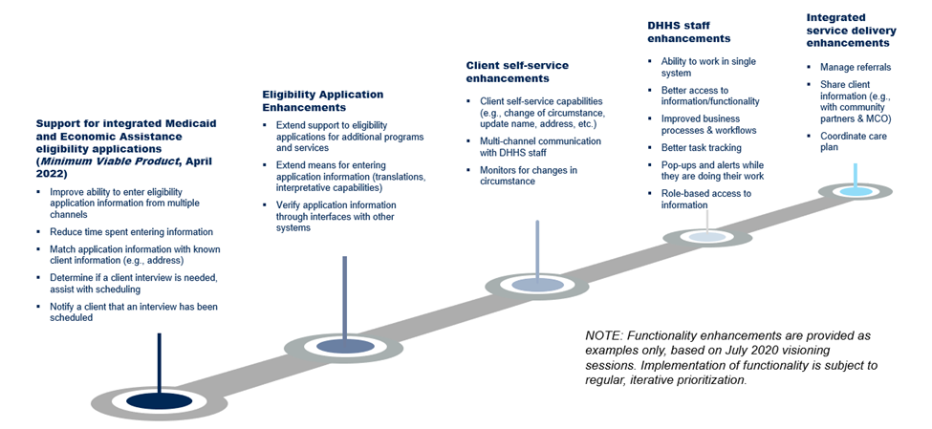

* + 1. iServe Nebraska Platform Technical Solution Pattern

The iServe Nebraska Platform will provide core common shared technology components and services that will be “consumed” or leveraged by the program specific solutions for iServe Nebraska, as shown in the Figure below. These business-enabling technology components are envisioned to allow DHHS to procure and implement capabilities that will enable customers, DHHS workers, and provider partners, to develop a customer-centric model of practice supported by an agile, integrated and more supportable set of technologies in meeting DHHS decision support (at all levels) requirements for its programs and services.

1. iServe Nebraska Technical Solution Pattern / Architecture Future State Conceptual View

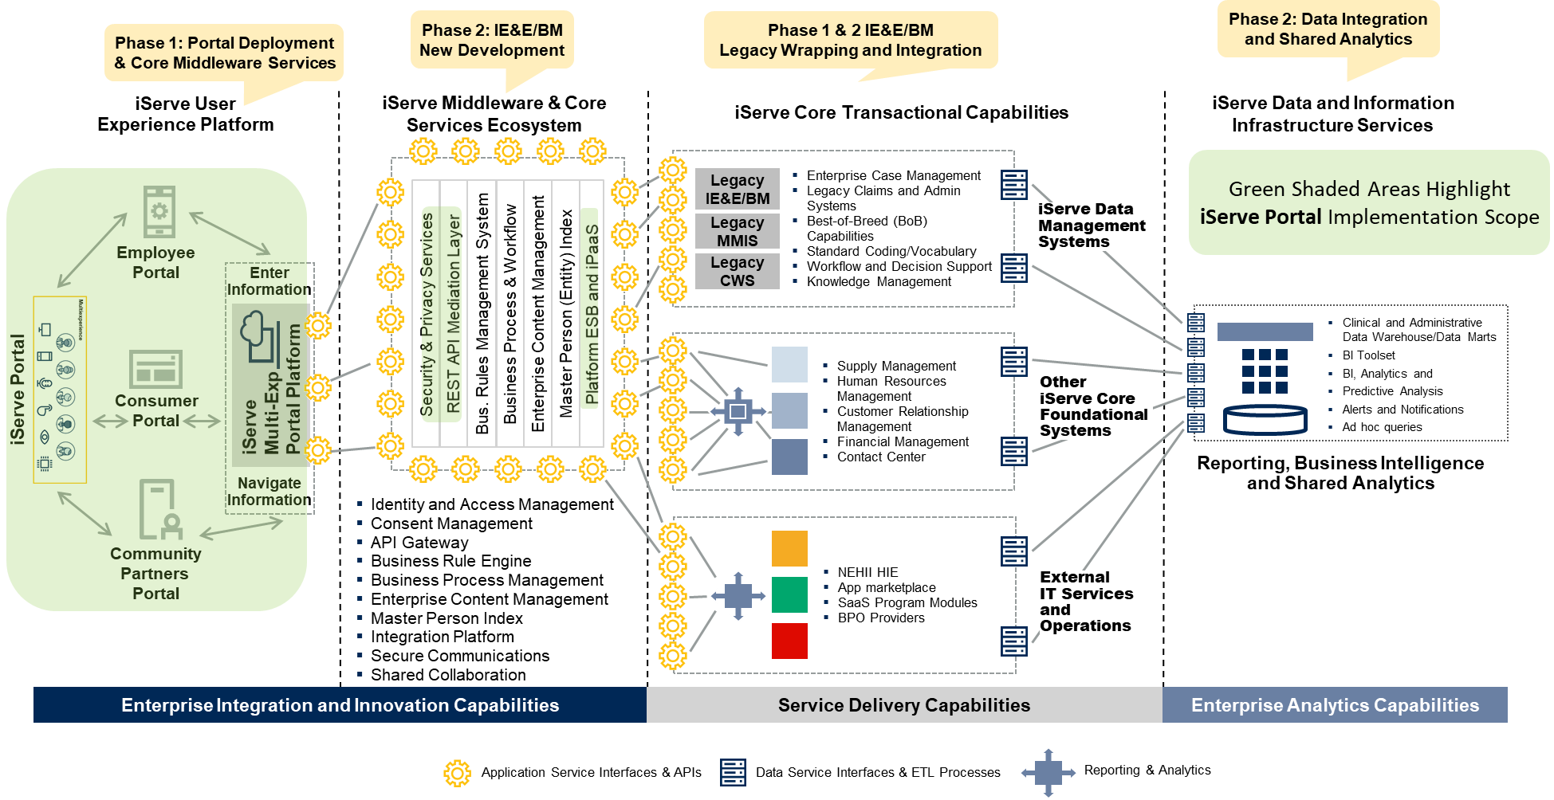

DHHS will first prioritize the business and technical capabilities that would provide the highest value to Nebraskans, and then analyze the functionality to be leveraged from NFOCUS along with the new technology components to deliver the new business capabilities, This analysis by the core iServe team and the implementation partner will focus the NFOCUS modernization efforts on specific functionality of the system that needs to be wrapped and made available via the Application Programming Interface to the wrapped Application module or component. Over time, NFOCUS is expected to become more modular as new capabilities are delivered, and the iServe Platform development team will begin to migrate or replace certain modules onto newer, modern development languages, platforms and technologies.

The following Figure provides an overview of the 5 key solution component layers that together will support the iServe Nebraska Platform functional capabilities.

1. iServe Nebraska Platform components across architectural layers

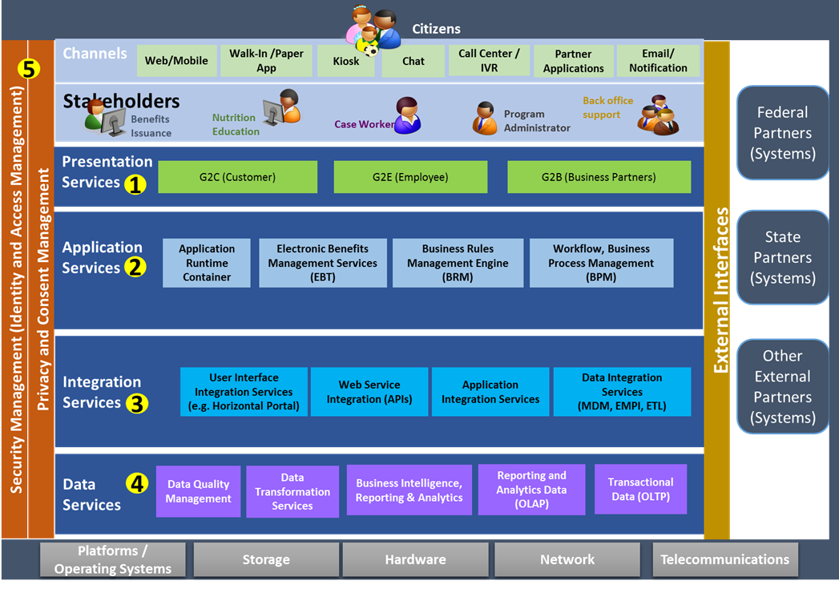

* 1. Document Purpose

The purpose of this document is to present the business process functionality to be provided for Integrated Benefits Eligibility and Enrollment Management (IBEEM), starting with the key iServe Nebraska Platform components and functionality that directly interact with the consumer, specifically the **iServe Nebraska Portal implementation**. This document provides a comprehensive view of the State’s future business model and functional requirements that are in scope for the **iServe Nebraska Portal Minimum Viable Product (MVP)** based on the information available about the potential Portal technology platforms that DHHS may implement.

The Minimum Viable Product is a shorthand reference to the minimum number of automation features and capabilities that can be released into the live production environment within a targeted timeline, using the desired modern technology, to deliver highly valuable and desirable functionality to the consumer. Given that DHHS has been delivering consumer facing functionality via AccessNebraska for the last few years, the iServe core team and Portal implementation partner will look to completely replace the current functionality available through AccessNebraska by April 2022. However, if it becomes clear to the core team that this goal cannot be met, the development teams will be directed to fully integrate any remaining functionality that is only available through AccessNebraska into the iServe Portal by April 2022. DHHS expects the implementation partner to conduct an in-depth review and analysis of the current AccessNebraska functionality as a part of its initial Program Increment and development planning process to ensure a full understanding of what has to be delivered by April 2022.

This document, including the functional and non-functional requirements, should be used in conjunction with the general system design defined by the State to:

* Provide internal and/or external technology partners with a sufficient understanding of the scope and complexity required to design, build and implement the iServe Nebraska Portal MVP in order to allow accurate estimates of schedule and cost
* Provide Nebraska users with a common language to articulate their understanding of the iServe Nebraska Portal capabilities
* Allow users to discuss “what” the iServe Nebraska Portal needs to do and not “how” it should do it (i.e., not providing constraints for a design)

Please note that once this document is completed, it will include the full business process functionality for the iServe Nebraska Portal MVP and the IBEEM solution.

1. Approach and Methodology

The Life of the Case (LOC) Methodology™ was used – with many DHHS subject matter experts from across DHHS programs and services – to review, assess, and identify the functional requirements for the iServe Nebraska Portal MVP. The LOC uses program and policy specific views of the life of DHHS client services from both the perspective of the client and DHHS staff and partners.

The resulting *future state* workflows and use cases constitute the definition of DHHS iServe Nebraska Business Architecture and support the definition of requirements. The Life of the Case provides a view of how clients and partner organizations interact; ensuring use cases and requirements are focused on supporting the business processes. It is important to note that the requirements are “what” DHHS expects the iServe Nebraska technologies to support, starting with the iServe Nebraska Portal, and not the definition of the “how” the technologies will be developed.

The approach to the IBEEM and iServe Nebraska Portal requirements definition includes four key steps:

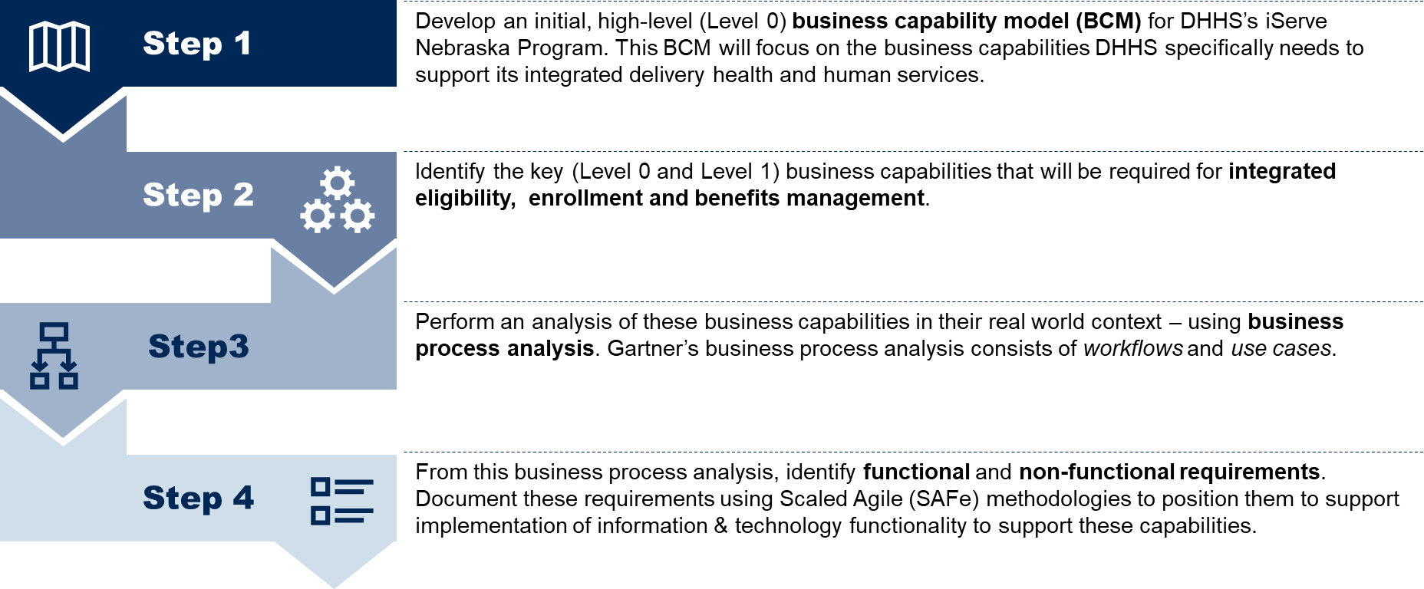

A process review / workshop approach was employed in order to quickly gather input from a diverse group of participants representing various stakeholder groups including DHHS business and technology subject matter experts. The primary objectives of the functional workshops were:

* Define and validate the future state business processes and use cases, including opportunities for improving the current state model of practice through the implementation of technology
* Identify opportunities for data sharing based on the information required to accomplish each process flow
* Define and validate functional requirements using the Scaled Agile (SAFe) methodology, in terms of capability and feature. For each capability or feature, identify the business (user) capabilities or features and the enabler capabilities or features

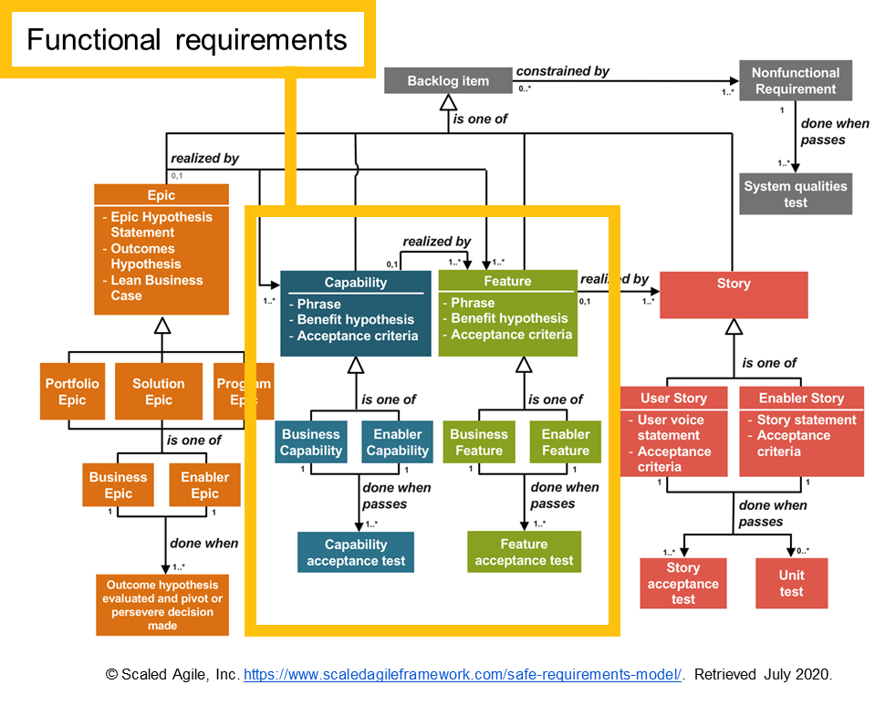

The primary objectives of the General System Design workshops focused on the iServe Nebraska Portal, within the context of the overall iServe Nebraska Integration Platform were to:

* Establish guiding principles that would provide day-to-day guidance on execution-related decision making
* Identify a preferred software design pattern to achieve the vision for iServe Nebraska Portal
* Identify the short list of vendors and technologies that would form the foundation for iServe Nebraska Portal and adhere to SAFe guidelines:
* Assume variability; preserve options (use of set-based design options)
* Build incrementally with fast, integrated learning cycles (use of architecture spikes to validate assumptions)
* Avoid the challenges of “big design up front,” including lengthy initial requirements definition and the risks associated with requirements “lock-in,” by taking an agile process, for both procurement and design, development and implementation of iServe Portal and Platform technologies

The information gathered and validated in the workshops was used to create this document as well as the General System Design.

Based on the use case analysis and General System Design work, the DHHS team defined a set of non-functional requirements which, in SAFe terminology, are system attributes such as security, reliability, performance, maintainability, scalability and usability. These requirements serve as constraints or restrictions on the design of the future solution.

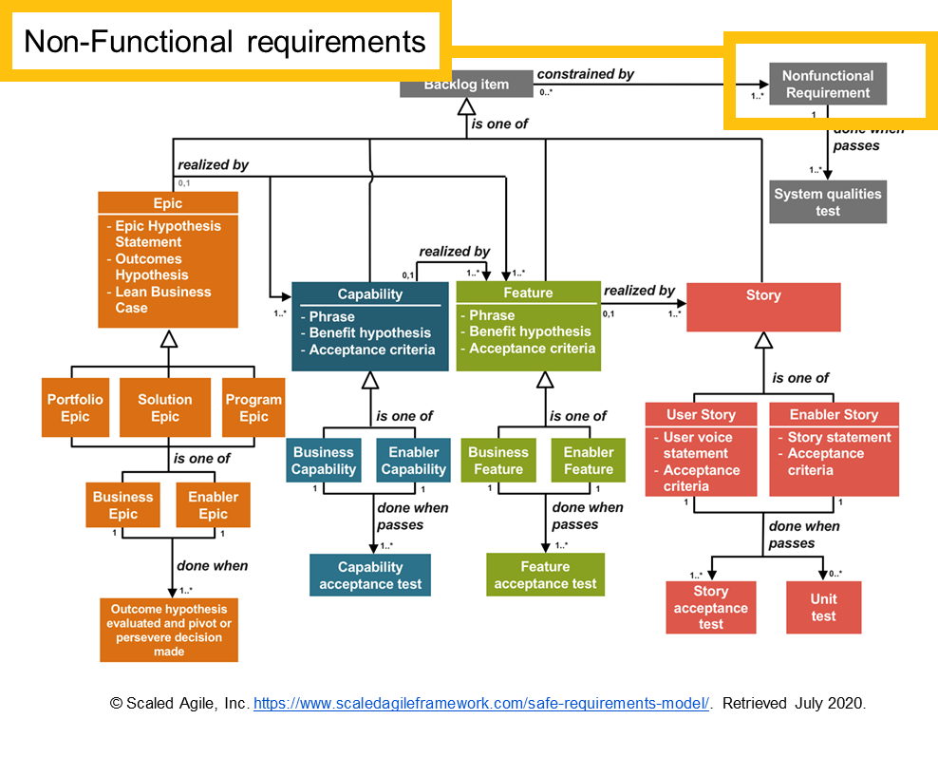

Together, these artifacts provide a comprehensive view of the requirements needed to perform specific functions in the future state.

1. iServe Nebraska Business Capabilities Model
   1. Overview

A Business Capability Model (BCM) is a visual tool that provides a simple view of the business. It creates a common taxonomy that stakeholders can use to describe the capabilities that the business must perform to fulfill its mission and achieve its objectives.

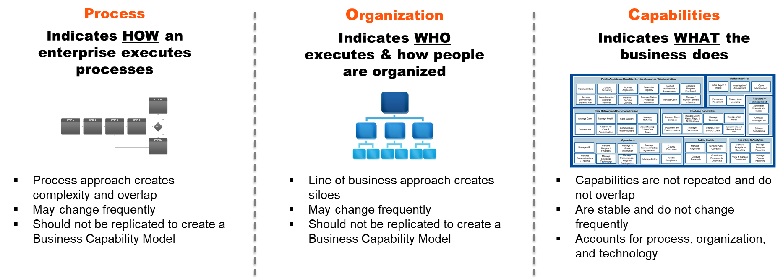

In the context of Nebraska DHHS, business capabilities are things DHHS must do in order to fulfill its mission and meet its strategic objectives. DHHS requires many different types of business capabilities. As depicted below, some of these are unique to the delivery of integrated health and human services. Of these integrated HHS business capabilities, some are specifically related to integrated eligibility application, determination and enrollment as well as benefits management. The BCM will provide a way of articulating what business capabilities are related to IBEEM at an increasingly granular level.

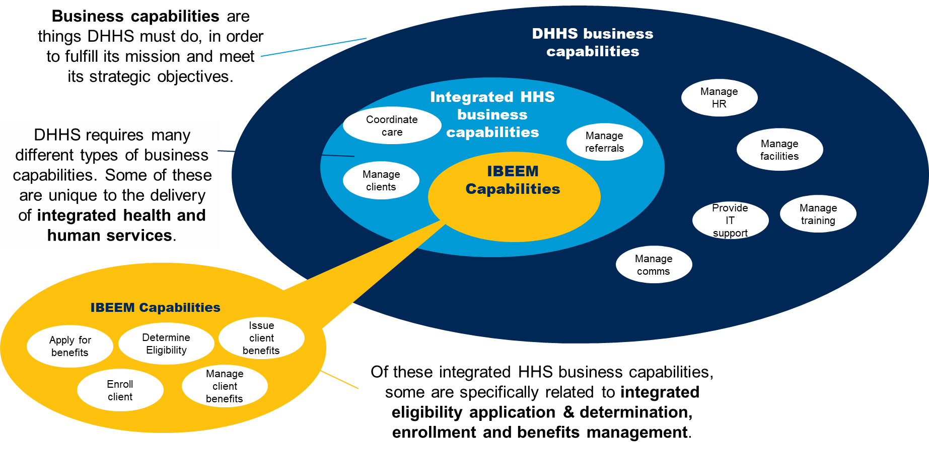

The BCM will provide a way of articulating what business capabilities are related to IBEEM at an increasingly granular level.

* 1. DHHS Business Capabilities (Level 0)

The DHHS Business Capability Model (level 0) includes the following key capabilities related to the iServe Nebraska Portal:

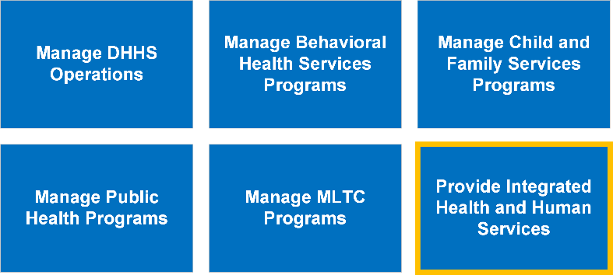

* 1. iServe Nebraska Business Capabilities (Level 1)

The DHHS Business Capability Model (level 1) for the iServe Nebraska Program (“Provide Integrated Health and Human Services”) includes the following key capabilities related to the iServe Nebraska Portal:

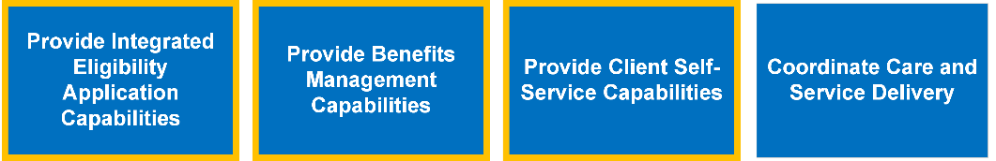

* 1. Integrated Benefits Eligibility and Enrollment Management (IBEEM) Business Capabilities (Level 2)

The DHHS Business Capability Model (level 2) for iServe Nebraska Integrated Benefits Eligibility and Enrollment Management (IBEEM) includes the following key capabilities related to the iServe Nebraska Portal:

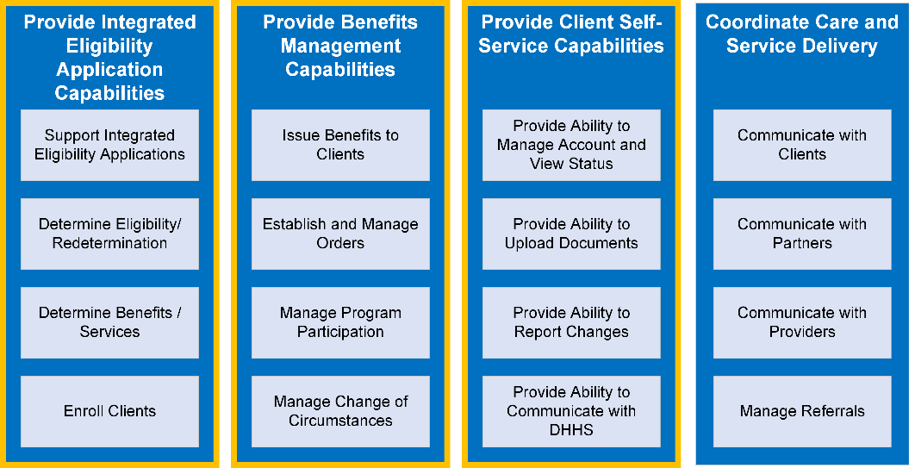

1. iServe Nebraska Portal Stakeholder Analysis

A stakeholder analysis is an important technique for stakeholder identification and the analysis of their needs. In the context of Nebraska DHHS, the stakeholder analysis outlined below considers who will use the iServe Nebraska Portal, what they will use it for and how they will use it.

Please note: The Stakeholder Analysis below is not intended to be exhaustive or final. This will be iterated and updated throughout the requirements development process with DHHS.

* 1. Consumer Stakeholders
     1. Applicants/Clients

DHHS serves a diverse client population, including many with limited experience using technology, constrained access to computing devices, physical and cognitive/intellectual disabilities, as well as those for whom English is a second language. DHHS primary goals for the iServe Nebraska Portal is to provide these clients with an intuitive, easy-to-use interface with a consistent look and feel regardless of device used to access. The iServe Nebraska Portal should focus on providing these clients with:

* Access to information on DHHS program and services. Given the complex nature of the Federal and State health and human services programs that DHHS administers, the iServe Nebraska Portal will need to ensure that this information is easy to understand, and be comprehensible to the client, regardless of the client’s primary language or reading level.
* Self-service tools and capabilities, to submit applications, view application status, view benefit information, report change of circumstances, and communicate with DHHS

|  |  |  |  |
| --- | --- | --- | --- |
|  |  | System Actions | Access Mediums |
| * Access / Intake   + - Complete IE pre-screening to receive recommendations for which eligibility programs to apply to     - Submit new application for NE DHHS programs or services – via Portal or paper/in-person * Eligibility Determination   + - Check status of eligibility and enrollment * Self-Service   + - Create and manage iServe Nebraska account (including communication preferences)     - Log in / log out of iServe Nebraska Portal     - Search for / look-up information     - Send and receive secure messages     - Upload files and supporting documentation     - Schedule and manage appointments     - Report a change     - Submit renewal applications for NE DHHS programs or services – via Portal or paper/in-person * Shared Capabilities   + - Access and view System generated alerts and notifications     - Access and view Client dashboard | | * Mobile device / tablet * Web browser (computer/laptop) | |

* + 1. Parent or Legal Guardian / Authorized Representative

During the course of the interactions with DHHS, applicants/clients may be assisted by several types of authorized representatives. These include, but are not limited to:

* Parents or Legal Guardians
* Power of Attorney
* Community partners, including application counselors, navigators, agents, and brokers

For each of these roles, the applicant/client must formally authorize the person to view their information and act on their behalf, including the scope of the actions they can perform and information they can view, and the duration of the authorization.

|  |  |
| --- | --- |
| System Actions | Access Mediums |
| * Access / Intake – *On behalf of a client…*   + - Complete IE pre-screening to receive recommendations for which eligibility programs to apply to     - Submit new application for NE DHHS programs or services – via Portal or paper/in-person * Eligibility Determination – *On behalf of client…*   + - Check status of eligibility and enrollment * Self-Service – *On behalf of client…*   + - Create and manage iServe Nebraska account (including communication preferences)     - Log in / log out of iServe Nebraska Portal     - Search for / look-up information     - Send and receive secure messages     - Upload files and supporting documentation     - Schedule and manage appointments     - Report a change     - Submit renewal applications for NE DHHS programs or services – via Portal or paper/in-person * Shared Capabilities – *On behalf of client…*   + - Access and view System generated alerts and notifications     - Access and view Client dashboard | * Mobile device / tablet * Web browser (computer/laptop) |

* + 1. Key Needs, Pain Points and Opportunities for Improvement

|  |  |  |  |  |
| --- | --- | --- | --- | --- |
| Find the information I need | Do things myself | Know where things stand | Pain Points/ Frustrations | Opportunities/ Quick Wins |
| * Information on DHHS programs and services * How to apply, including what I need to apply * Understand rules, regulations and requirements related to representatives completing processes for another person | * Apply for services and renewals * Upload documentation to support eligibility applications or renewals * Report change of circumstances * Communicate with DHHS * Request proof of coverage and/or Medicaid card * Print notices and other important documents | * Status of application * Status of current enrollment | * Consumers don't know where to access information * Language is hard to understand (e.g., should be 5th grade reading level) * Confusion regarding federal vs state programs and services | * Consumers don't know where to access information * Language is hard to understand (e.g., should be 5th grade reading level) * Confusion regarding federal vs state programs and services |

* 1. DHHS Staff

Members of DHHS staff will use the iServe Nebraska Portal to complete many types of actions related to integrated benefits, eligibility and enrollment management. One of the primary goals for the iServe Nebraska Portal is to provide an easy-to-use interface for these DHHS staff persons, allowing them to complete tasks related to application and client/case management, as well as to communicate with applicants/clients, their authorized representatives, or DHHS’s partners in the provision and delivery of services.

|  |  |
| --- | --- |
| System Actions | Access Mediums |
| * Access/Intake   + - Assist applicants/clients (or their authorized representative) in:     - Completing IE pre-screening     - Submitting IE application via Portal     - Manage applications     - Provide application-related troubleshooting and technical support     - Provide recommendations for which eligibility programs a Client / Patient can apply to * Eligibility Determination   + - Validate/verify application-related information     - Process applications (including renewals)     - Conduct IE interviews     - Determine eligibility     - Check status of eligibility and enrollment application / renewal * Client Case/Benefit Management   + - Search for / look-up client/case information     - Issue client benefits     - Process changes in client circumstances     - Process paper documentation     - Manage caseload/worker assignment     - Manage referrals     - Send and receive secure messages     - Manage a schedule of appointments     - Upload files and supporting documentation * Self-Service   + - Update information on DHHS programs and services     - Manage notices & alerts     - Access and view standard and parameter-based reports     - Create ad hoc queries & reports | * Mobile device / tablet * Web browser (computer/laptop) |

* Access/Intake
  + - Assist applicants/clients (or their authorized representative) in:
      * + Completing IE pre-screening
        + Submitting IE application via Portal
    - Manage applications
    - Provide application-related troubleshooting and technical support
    - Provide recommendations for which eligibility programs a Client / Patient can apply to
* Eligibility Determination
  + - Validate/verify application-related information
    - Process applications (including renewals)
    - Conduct IE interviews
    - Determine eligibility
    - renewal
* Client Case/Benefit Management
  + - Search for / look-up client/case information
    - Issue client benefits
    - Process changes in client circumstances
    - Process paper documentation
    - Manage caseload/worker assignment
    - Manage referrals
    - Send and receive secure messages
    - Manage a schedule of appointments
    - Upload files and supporting documentation
* Self-Service
  + - UpdateManage notices & alerts
    - Access and view standard and parameter-based reports
    1. Create ad hoc queries & reports Key Needs, Pain Points and Opportunities for Improvement

|  |  |  |  |  |
| --- | --- | --- | --- | --- |
| Find the information I need | Do things myself | Know where things stand | Pain Points/ Frustrations | Opportunities/ Quick Wins |
| * Access client information, including application information * Find policy and procedure information | * Communicate with clients, other DHHS staff, as well as com-munity partners & providers * Make referrals | * Current status of applications, benefits | * Arduous, manual workarounds * Current system does not empower or enable consumers to access or find information on their own; go to DHHS staff/workers frequently | * More automation * Improved user interface / more user friendly * Directly linking eligibility rules to policy |

* 1. Community Partners & Providers

DHHS collaborates with a wide array of community partners and providers to support applicants and clients in the integrated benefits, eligibility and enrollment process. These partners may:

* Assist clients with using the iServe Nebraska Portal
* Provide computers for clients to apply online
* Provide printer access for System documents
* Provide information handouts
* Assist clients with applying for DHHS programs and services

|  |  |
| --- | --- |
| System Actions | Access Mediums |
| * Access / Intake   + - Assist applicants in completing IE pre-screening to receive recommendations for which eligibility programs to apply to     - Assist applicants in submitting new application for NE DHHS programs or services – via Portal or paper/in-person * Eligibility Determination   + - Assist applicants in checking on the status of eligibility and enrollment * Self-Service   + - Update information on DHHS partners and services     - Create and manage iServe Nebraska account (including communication preferences)     - Log in / log out of iServe Nebraska Portal     - Search for / look-up information     - Send and receive secure messages     - Upload files and supporting documentation     - Schedule and manage appointments     - Communicate with DHHS * Shared Capabilities   + - Access and view System generated alerts and notifications | * Mobile device / tablet * Web browser (computer/laptop) |

* + 1. Key Needs, Pain Points and Opportunities for Improvement

|  |  |  |  |  |
| --- | --- | --- | --- | --- |
| Find the information I need | Do things myself | Know where things stand | Pain Points/ Frustrations | Opportunities/ Quick Wins |
| * Access client information, with appropriate access * Find policy and procedure information | * Provide DHHS with materials supporting eligibility determination and enrollment * Manage referrals * Communicate with DHHS staff | * Current status of eligibility applications, benefits * Current status of referrals |  |  |

1. iServe Nebraska Portal MVP & IBEEM Scope

Table 1 describes the scope of process flows and use cases for the iServe Nebraska Portal minimum viable product (MVP). The table also includes process flows and use cases that will be defined to support the procurement of other iServe Nebraska Platform components required for Integrated Benefits, Eligibility& Enrollment Management (IBEEM) functionality.

|  |  |  |
| --- | --- | --- |
| Access/Medicaid Presumptive Eligibility Determination | | |
| Send Information/Verification Request Client Self-Service | | |
| Client Case / Benefit Management |
| * Designate Authorized Representative |  | X |
| * View Client/Case Information |  | X |
| * Manage Caseload/Worker Assignment |  | X |
| HCBS ID/DD Waiver Application Management | | |
| * Apply for HCBS ID/DD Waiver Programs |  | X |
| * Assess Level of Care |  | X |
| * Manage Waitlist |  | X |
| * Determine Individual Budget Amount |  | X |
| Appeals Management | | |
| * File Appeal |  | X |
| * Conduct Hearing |  | X |
| * Issue Appeal Decision |  | X |
| Shared Capabilities | | |

1. In-Scope Business Processes

|  |  |  |
| --- | --- | --- |
| Business Process | iServe Nebraska Portal MVP | IBEEM Scope |
| Intake |  |  |
| Integrated Eligibility (IE) Pre-Screening | X |  |
| Submit IE Application via Portal | X |  |
| Submit IE Application via iServe Nebraska Portal with Assistance |  | X |
| Submit IE Application via Paper Application |  | X |
| Medicaid Presumptive Eligibility |  | X |
| Eligibility Determination |  |  |
| Process IE Application |  | X |
| Conduct IE Interview |  | X |
| Determine Eligibility |  | X |
| Send Information/Verification Request |  | X |
| Client Self-Service |  |  |
| Create iServe Nebraska Account | X |  |
| Log in / Log out of iServe Nebraska Portal | X |  |
| Send / Receive Secure Message | X |  |
| Upload Files (on behalf of Applicant/Client) | X |  |
| Schedule an Appointment |  | X |
| Report a Change of Circumstance |  | X |
| Renewal / Redetermination / Recertification |  | X |
| Client Case/Benefit Management |  |  |
| Designate Authorized Representative |  | X |
| Client Search and Look-Up |  | X |
| Issue Client Benefits |  | X |
| Process a Change of Circumstance |  | X |
| Manage Referrals |  | X |
| Process Paper Documentation |  | X |
| Manage Task Assignment |  | X |
| HCBS ID/DD Waiver Application Management |  |  |
| Apply for HCBS DD Waiver Program |  | X |
| Assess Level of Care |  | X |
| Manage Waitlist |  | X |
| Child Care Management |  |  |
| Select Child Care Provider |  | X |
| Child Care Provider Payment |  | X |
| Appeals Management |  |  |
| File Appeal |  | X |
| Conduct Hearing |  | X |
| Shared Capabilities |  |  |
| Manage Notices & Alerts |  | X |
| Access and View Standard, Parameter-based Reports |  | X |
| Create Ad Hoc Queries and Reports |  | X |

NOTE: The list of IBEEM business processes will evolve as the project team moves through the IBEEM workshops in the fall of 2020.

Below are the programs that have been identified as in-scope for the IBEEM and the iServe Nebraska Portal MVP:

|  |  |
| --- | --- |
| * Medicaid, including:   + - Medicaid services, including Personal Assistance Services (PAS)     - HCBS Waivers, including:       * + Intellectual/Developmental Disabilities (ID/DD) Waiver Programs         + Medicaid Aged and Disabled (AD) Waiver         + Katie Beckett Program         + Program of All-Inclusive Care for the Elderly (PACE)         + Traumatic Brain Injury (TBI) Waiver   NOTE: Due to unique nature of HCBS waiver application and enrollment process, these programs are considered out-of-scope for iServe Nebraska Portal MVP, though in-scope for the IBEEM effort.   * Children’s Health Insurance Program (CHIP) | * Economic Assistance, including:   + - Supplemental Nutrition Assistance Program (SNAP)     - Aid to Dependent Children (ADC)/Temporary Assistance for Needy Families (TANF)     - Energy Assistance (LIHEAP)     - Aid to the Aged, Blind, or Disabled (AABD)     - Child Care     - Social Services Aged and Disabled Adults (SSAD)     - Social Services Children and Families (SSCF) |

As with any project, changes to the scope are expected. If/when the DHHS decides to add or remove capabilities from the scope, the change will be documented (e.g., on an Issues log) and reviewed by Executives and a decision will be documented on whether and how to proceed.

The iServe Nebraska team wants to follow and implement the best of breed technology and strategies for Integrated Benefits Eligibility and Enrollment Management (IBEEM). The Implementation Partner should be well aware of similar Integrated Eligibility projects around the country and keep the iServe Nebraska team informed of the failures and successes of other state-run Integrated Eligibility projects so the iServe Nebraska team can learn from those regional and national trends.

1. iServe Nebraska Portal MVP Process Flows
   1. Overview

End-to-end process flows have been developed and validated by DHHS to better understand the scope of the iServe Nebraska Portal MVP. Figure 1 below graphically captures the generic framework that depicts in sequential order all the business functionality throughout the Life of the CaseTM for the IBEEM solution, including the iServe Nebraska Portal MVP functionality.

1. IBEEM Key Business Functionality – to be validated with DHHS Stakeholders

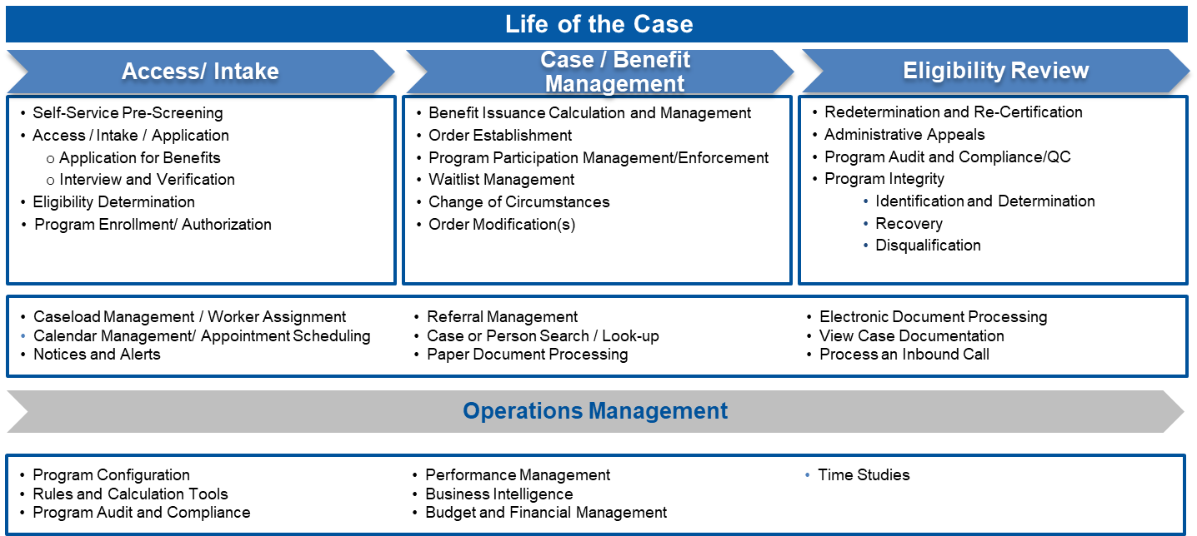

In collaboration with DHHS, future state process flows were evaluated, and end-to-end process flows that capture the flow between the major activities were developed. Associated use cases provide a narrative within which the activities are performed.

* 1. Workflow Notations

A standard notation is used to document the Process Flows. Refer to the figure below for a summary of the notation and a description of how each notation is used.

1. Process Flow Key



* 1. Access / Intake
     1. Process Flow 1 (PF1): Integrated Eligibility Pre-Screening

The figure below represents the flow of activities for a Nebraska resident to conduct anonymous pre-screening and to select to proceed to complete and submit an application.

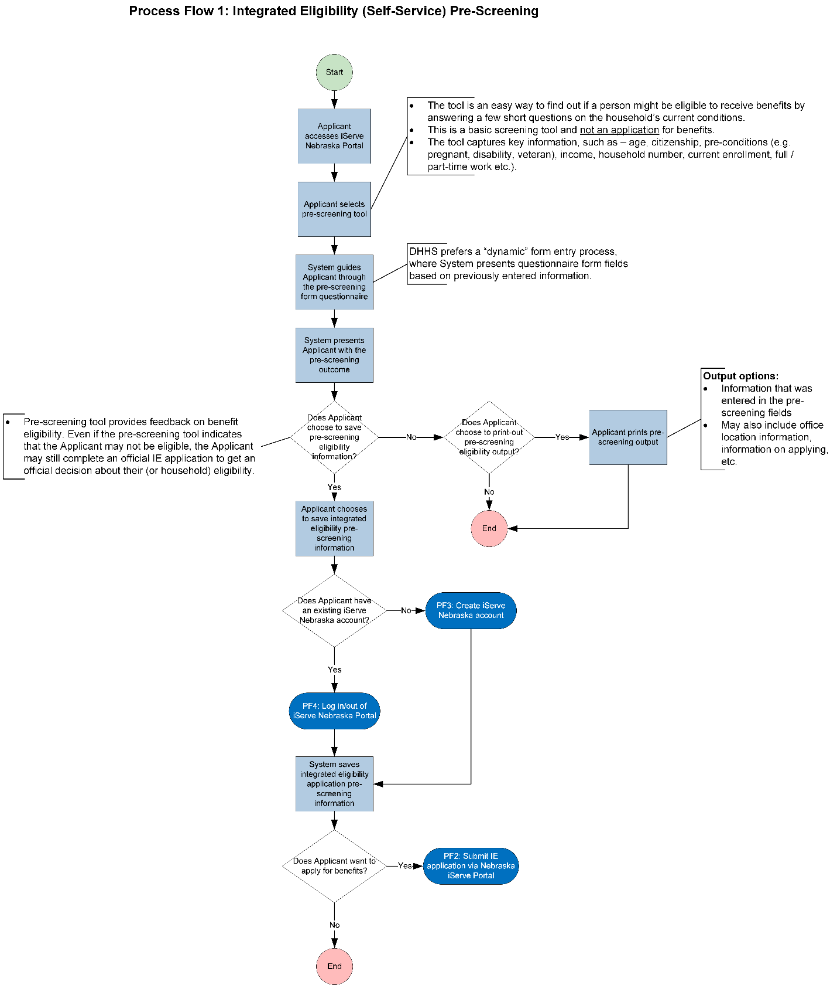

* + 1. Process Flow 2 (PF2): Submit IE Application via iServe Nebraska Portal

The figure below represents the flow of activities for the Nebraska resident to complete and submit an integrated application for the programs in-scope via the iServe Nebraska Portal.

*Note: Due to size, this process flow image has been divided into two parts.*





* 1. Client Self-Service
     1. Process Flow 3 (PF3): Create iServe Nebraska Account

This represents the activities for an Applicant to create an account to log into the iServe Nebraska Portal and apply for services.

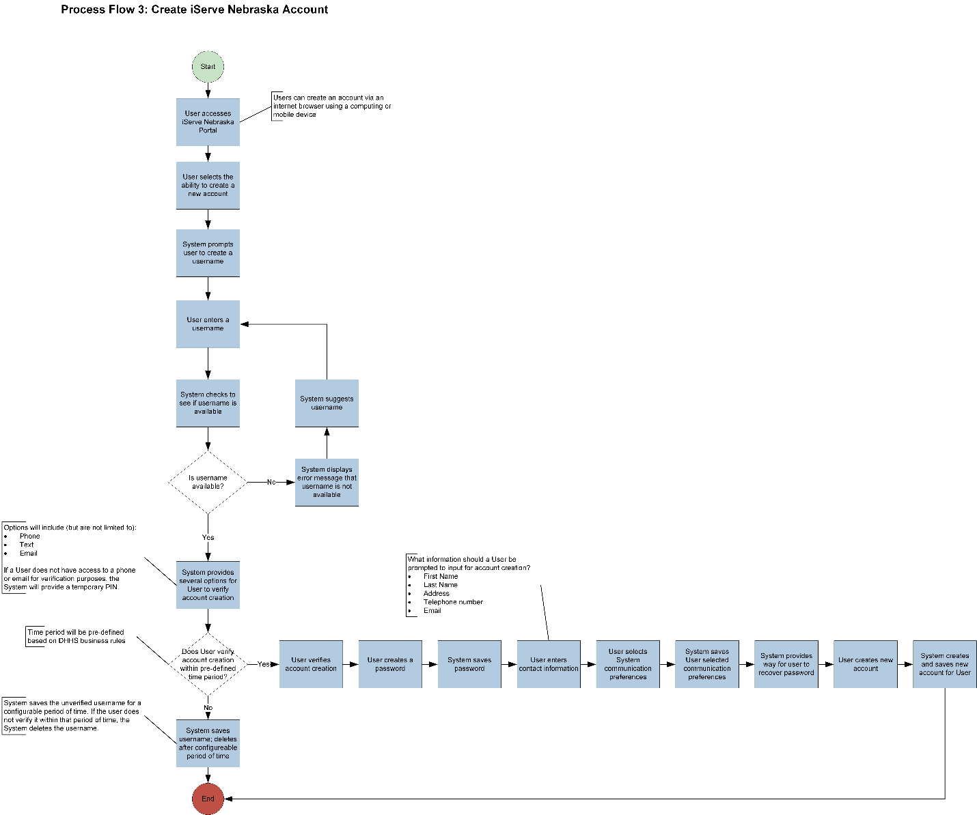

* + 1. Process Flow 4 (PF4): Log in / Log out of iServe Nebraska Portal

This represents the activities for a Client (or Applicant) to access the iServe Nebraska Portal with their own credentials.

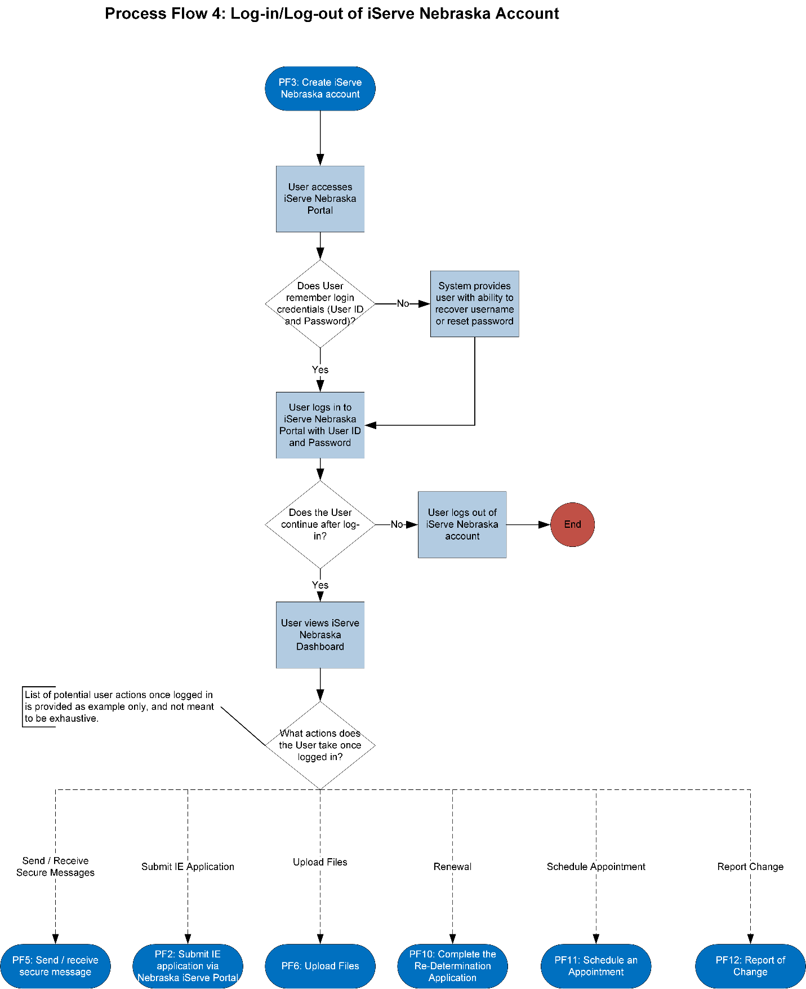

* + 1. Process Flow 5 (PF5): Send / Receive secure message

This represents the activities for a DHHS Worker to send or receive secure messages via the iServe Nebraska Portal.

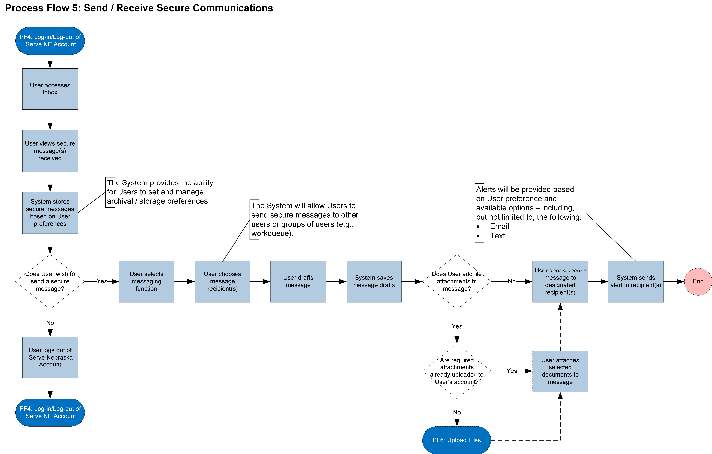

* + 1. Process Flow 6 (PF6): Upload files

This business process includes the activities required for the Client to log onto the System and submit documentation of any sort. The System then assesses the Client’s case to identify the next actions, including sending notifications.

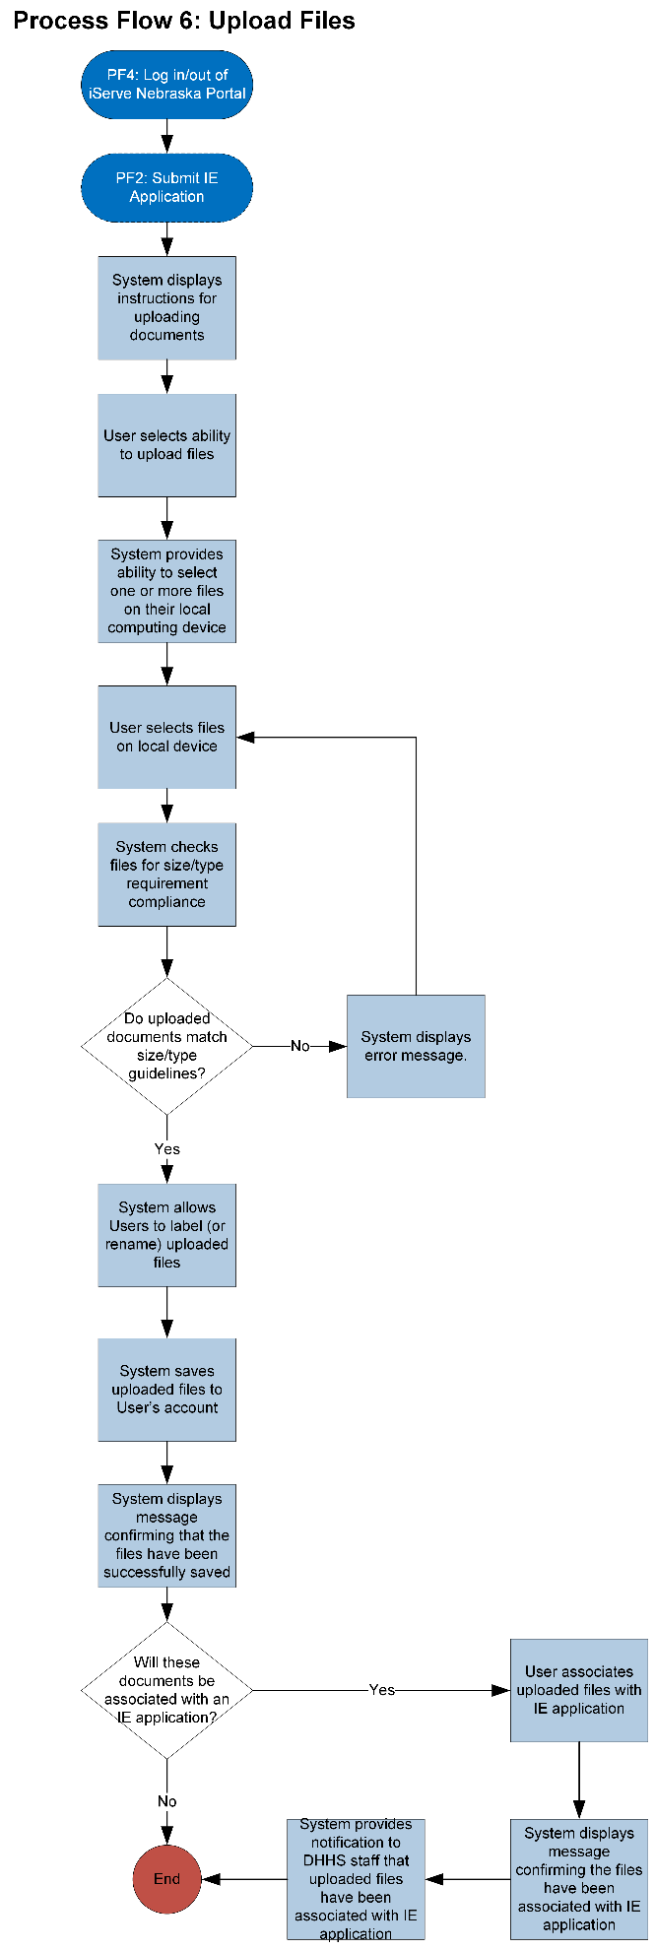

1. iServe Nebraska Portal MVP Use Cases
   1. Overview

Use Cases capture the requirements from a client and user perspective. Each Use Case represents the course of events for a business process (e.g., Apply for Benefits Online) to be completed. The purpose of the Use Cases is to illustrate *what* the System is expected to do in supporting specific business processes for the programs in scope. Key aspects of a use case include:

* Each use case follows the actions of at least one “actor”
* A “trigger” causes an actor to interact with the system until a process is completed (example triggers may include the submission of an application, or the receipt of a request)
* A use case represents the complete course of events for the business process (e.g., review and application)
* A use case illustrates what the system is expected to do, but is not intended to provide a particular design or to describe how the system will technically complete the activity

Each Use Case contains the following information:

* Use Case Title
* Actor(s) — Person interacting with the System
* Background(s) — Background information and To-Be goals
* Objective(s) — The desired outcome
* Trigger(s) — What initiates or provokes the first step
* Pre-Condition(s) — What will be in place before
* Post-Condition(s) — What will be in place after
* Main Flow — The process steps listed
* Alternative Flow(s) – Variable steps (as needed)
* Interfaces — External systems with which the Use Case shares information
  1. Access/Intake
     1. Use Case 1 (UC1): Integrated Eligibility Pre-Screening

|  |  |
| --- | --- |
| Actors | * Any person |
| Background | * Applicant fills out an anonymous, online questionnaire to receive preliminary feedback of their eligibility for the DHHS programs in scope. * The eligibility screening does not guarantee eligibility for the Applicant. It informs them whether filling out the entire integrated eligibility application would likely be successful and for which programs they would most likely be eligible. * DHHS programs in-scope for IE Pre-Screening include:   + - Medicaid, including:       * + Children’s Health Insurance Program (CHIP)         + Personal Assistance Services (PAS)     - Economic Assistance, including:       * + Supplemental Nutrition Assistance Program (SNAP)         + Low Income Home Energy Assistance Program (LIHEAP)         + Refugee Resettlement Program         + Aid to Dependent Children (ADC) / Temporary Assistance to Needy Families (TANF)         + Child Care (CC)         + Social Services for Families, Children and Youth (SSCF)         + Emergency Assistance (EA)         + Aged, Blind, or Disabled (AABD)         + State Disability Program (SDP)         + Social Services Aged and Disabled Adults (SSAD) |
| Objectives | * Provide the ability for NE resident to quickly and easily receive automated guidance 24/7 regarding which DHHS programs for which they may be eligible |
| Pre-Condition | * Applicant has access to a computing device (e.g., desktop/laptop) or mobile device (e.g., iPhone, Android) with an internet browser (e.g., Google Chrome, Mozilla Firefox, Apple Safari) * Applicant has the required information to complete the pre-screening. |
| Trigger Event | * Applicant visits the iServe Nebraska Portal, and chooses to complete the anonymous pre-screening tool. |
| Post-Condition | * Applicant receives guidance on their potential eligibility. * Applicant receives guidance on the next steps for completing the Integrated Eligibility Application, if desired. |

* + - 1. Main Flow

1. Applicant accesses the iServe Nebraska Portal via an internet browser, using a computing or mobile device.
2. Via the iServe Nebraska Portal interface, Applicant selects the ability to complete the anonymous pre-screening eligibility tool.
3. The System allows the Applicant to choose one or more specific State Program(s), or all Programs to estimate eligibility.
4. The System displays a step-by-step questionnaire which collects the minimal data required to pre-screen for eligibility for the DHHS programs the Applicant has chosen. If the Applicant chooses specific DHHS programs, the System will ask only those questions required to make a preliminary eligibility determination for the chosen programs. Data elements may include, but are not limited to, the following:
   * + Residency
       - * Whether or not the Applicant is (or will be) in Nebraska temporarily or permanently. If the Applicant will be in Nebraska temporarily, the Applicant’s anticipated duration in the State
     + Household demographics and composition (as detailed as needed)
       - * Citizenship/alien status
         * Date of birth
     + Living arrangement, which may include but not be limited to the following options:
       - * Private dwelling
         * Homeless
         * Community program/nursing home
         * Live with others
     + Income
       - * Monthly salary, including all cash payments
         * If the Applicant does not know or cannot estimate their monthly salary, the System captures all current sources of income and will calculate the monthly salary
     + Current benefits received
       - * Program (SNAP, TANF, Medicaid, LIHEAP, etc.)
         * State from which benefit is received
     + Assets/Resources
       - * Total value greater than a State-specified amount (yes or no answer)
         * The System will provide guidance to the Applicant regarding which Assets/Resources to include in the calculation
     + Expenses
       - * Total monthly value
         * The System will provide guidance to the Applicant regarding which expenses to include in the calculation
     + Health Status
       - * Ability to work/perform activities of daily living
         * Disability
         * Pregnancy (current, delivered within last 60 days)
         * Referred by or need referral for mental health benefits
     + Refugee status
     + Benefits received during or after aging out of Foster Care
     + Program-specific disqualification questions
       - * Program violations (e.g., fraudulently receiving or duplicate SNAP benefits in any state after 9/22/96)
         * Drug violations
         * Probation or parole violations
     + Private health insurance status
5. Upon completion of the data entry, the tool provides the Applicant with the option to review the data and make any final changes.
6. The Applicant submits the request for pre-screening.
7. The System processes the entered information and displays all DHHS programs and benefits that the Applicant may qualify for, based on the data provided. The System displays information of the limitations of the guidance (e.g., the guidance is not a guarantee of eligibility)
8. If the Applicant does not appear to qualify for a specific Program, the System provides any available information regarding actions the Applicant may take such as seeking assistance from supplemental resources, including but not limited to:
   * + Other State Programs
     + Other local and non-State Programs that may assist the Applicant
9. The System provides the Applicant with the option to save the information in the System.
   1. If the Applicant proceeds to save the information, the System prompts the Applicant to either create an iServe Nebraska account (see **Use Case 3: Create iServe Nebraska Account)** or to log in to their iServe Nebraska Portal account (see **Use Case 4: Log-in/Log-Out of iServe Nebraska Portal**)
   2. If the Applicant does not choose to save the information, the System provides the Applicant with the ability to print the pre-screening eligibility information.
10. The System provides the Applicant with the option to apply (**Use Case 2: Submit IE Application via Portal)**
11. If the Applicant elects to apply in the same session and has created an account online, this allows information from the pre-screening data entry fields to be pre-populated into the integrated eligibility application, where appropriate.  
    NOTE: The Applicant has the ability to modify any data that has been prepopulated during the Application process.
    * 1. Use Case 2 (UC2): Submit IE Application via Portal

|  |  |
| --- | --- |
| Actors | * Applicant, including:   + - NE resident     - Non-NE resident[1] |
| Background | * A NE resident (Applicant) seeks one or more NE DHHS programs or services, including the following:   + - Medicaid, including:       * + Medicaid services, including Personal Assistance Services (PAS)     - Children’s Health Insurance Program (CHIP)     - Economic Assistance, including:       * + Supplemental Nutrition Assistance Program (SNAP)         + Aid to Dependent Children (ADC)/Temporary Assistance for Needy Families (TANF)         + Energy Assistance (LIHEAP)         + Aid to the Aged, Blind, or Disabled (AABD)         + Child Care (CC)         + Social Services Aged and Disabled Adults (SSAD)         + Social Services Children and Families (SSCF) * In-scope application information fields including, but are not limited to, those found on the following DHHS applications:   + - EA-117 – Application for Assistance     - MLTC 53 – Application for Medicaid and Insurance Affordability Programs     - MLTC 63 – Supplemental Application for Medicaid and Insurance Affordability Programs     - MLTC 64 – Application for Nebraska Medicaid for Aged and Disabled     - Additional DHHS forms as appropriate (e.g., Medically Frail, etc.) * This workflow is for an Applicant completing this application for herself/himself. Separate use cases will cover alternative application scenarios, including:   + - Submission of an Integrated Eligibility application with Assistance     - Submission of a Paper Integrated Eligibility application     - Submission of an Integrated Eligibility Application via Telephone (if/as required) * If the applicant is a current DHHS client, this workflow addresses submission of an eligibility application for programs or services in addition to the programs or services they are currently receiving. |
| Objectives | * Provide the ability for a NE resident (Applicant) to electronically complete an Integrated Eligibility application for one or more DHHS programs via the iServe Nebraska Portal. |
| Pre-Condition | * NE resident (Applicant) has access to a computing device (e.g., desktop/laptop) or mobile device (e.g., iPhone, Android) with an internet browser (e.g., Google Chrome, Mozilla Firefox, Apple Safari) * (Optional): NE resident has completed an Integrated Eligibility Pre-Screening application. |
| Trigger Event | * NE resident (Applicant) visits the iServe Nebraska Portal, and chooses to start an Integrated Eligibility application. |
| Post-Condition | * Applicant successfully submits an Integrated Eligibility application. * Applicant discards an un-submitted Integrated Eligibility application. |

* + - 1. Main Flow

1. NE resident (Applicant) accesses the iServe Nebraska Portal via an internet browser, using a computing or mobile device.
2. Via the iServe Nebraska interface, Applicant selects the ability to start an Integrated Eligibility application.
3. The system prompts the user to either:
   1. Create an iServe Nebraska account.   
      OR
   2. Log into their existing iServe Nebraska account.
4. Once the Applicant has logged in with an iServe Nebraska account, the Applicant uses the iServe Nebraska Portal to begin an Integrated Eligibility application.
5. The Applicant chooses which DHHS programs to apply for by either:
   1. Selecting one or more programs individually
   2. Selecting all programs
6. The System performs a check to determine if the Applicant is currently enrolled in any of the selected DHHS programs.
   1. If the Applicant is currently enrolled in any DHHS programs, the System displays to the Applicant that they are currently enrolled in the DHHS programs, and pertinent information, including, but not limited to:
      1. Current end date of enrollment
      2. Information about how to apply for renewal/redetermination to the DHHS program
7. The System requests Applicant consent for external and/or 3rd party data source lookups and pre-population of information.
   1. If the Applicant does not consent to external and/or 3rd party data source lookups, the System withdraws the Applicant’s application and notifies Applicant of withdrawal.
   2. If the Applicant gives consent to external and/or 3rd party data source lookups, the System attempts to identify the Applicant.
      1. If the System is unable to identify the Applicant, the System prompts the Applicant to provide information for identification.
      2. The Applicant either provides information needed for identification or proceeds to complete the application without initial identification.
8. Based on the programs the Applicant has selected to apply for, the System performs a look-up on internal and external data sources in order to pre-populate the application with known information on the Applicant. To do this, the System references internal and external data sources[2] – including, but not limited to, the following:
   1. Federal Data Services Hub
   2. Public Health Registries
   3. Nebraska Department of Motor Vehicles
   4. Social Security Administration (SSA)
   5. Public Assistance Reporting Information Systems (PARIS)
   6. (Nebraska and Federal) Department of Labor
   7. Electronic Disqualified Application System (eDRS)
   8. Nebraska Child Support Payment Center
   9. Nebraska Department of Correctional Services (State Prison, Federal Prison, and Juvenile Detention)
   10. National Directory of New Hires (NDNH)
   11. Department of Homeland Security (DHS) (SAVE System)
   12. US Census Bureau (to validate census tract)
   13. Postal Service (to validate address)
9. Using business rules based on the DHHS programs for which the Applicant is applying, the System presents to the Applicant with a series of application fields.
   1. Where the System can pre-populate information fields it does so.
   2. The System displays instructional information to assist the Applicant, including:
      1. Instructional information explaining the application field
      2. Instructional information on how to either revise pre-populated application field information, or how to enter new information
10. The Applicant revises pre-populated fields or enters information into each application field.
11. The System performs:
    1. Validation checks on information entered by the Applicant, such as validation that the data entered complies with each data field type (e.g., dates are entered in the correct format)
    2. As possible, verification on information entered by the Applicant, based on lookups to internal and external data sources.
    3. Validation check to determine whether the Applicant needs to upload additional documentation (see **Use Case 6: Upload Files**).
12. Applicant selects “Submit Application.”
13. The System validates that the Applicant has provided contact preferences.
    1. If contact preferences are not yet saved, the System prompts the Applicant to provide this information.
14. If the System determines that the information entered by the Applicant is either invalid or is not verified by internal or external data sources:
    1. The System flags the field and displays the reason for the information field error.
    2. The System prompts the Applicant to re-enter information.
15. If the System determines that the information entered by the applicant is valid, the System allows the Applicant to mark the IE application as complete.
16. Once the IE application is marked as complete by the Applicant, the System displays DHHS’s notice of privacy practices.
17. The Applicant authorizes a release of information to DHHS.
18. Using business rules based on the DHHS programs for which the Applicant is applying, the System prompts the Applicant to comply with applicable program requirements.
    1. If the Applicant complies with program requirements:
    2. If the Applicant does not comply with program requirements, DHHS staff document Applicant’s non-compliance and the System issues an application notice of denial.
19. The Applicant electronically signs their IE application.
20. If required, the System will notify the Applicant of a need for interview and will provide the option to have the interview immediately.
21. If the Applicant is applying for a Medicaid Managed Care program:
    1. The System displays information on Heritage Health plans available.
    2. The Applicant selects a plan.
       * 1. Alternative Flow A: Applicant Contacts DHHS for Assistance with Integrated Eligibility Application

At any point in the application process the System provides the Applicant with the ability to contact DHHS for assistance in completing the application.

#### Alternative Flow B: Applicant Chooses to Exit the Application

In the event the Applicant chooses to exit the application, the System provides the Applicant with the ability to save the draft application or to discard the application.

#### Alternative Flow C: Applicant is Required to Provide Supplemental Information

To support the integrated eligibility application submission process, the System will prompt the Applicant to upload supplemental documents and information (e.g., describe what is needed, where to obtain it, etc.).

* 1. Client Self-Service
     1. Use Case 3 (UC3): Create iServe Nebraska Account

This use case describes how an iServe Nebraska Portal user creates an account.

|  |  |
| --- | --- |
| Actors | iServe Nebraska Portal users, including, but not limited to the following stakeholder groups:   * Applicant * Client * Parent or Legal Guardian of Client * Authorized Representative of Client * NE DHHS staff * Healthcare Providers * NE DHHS Health Navigator / Community Health Worker * Community Partner Staff * Social Services Agency Staff * Employment Entity Staff |
| Background | * Only new Users may create an iServe Nebraska account; this workflow is not applicable to existing iServe Nebraska Users * Users only need one account to access all of the services available on the iServe Nebraska Portal |
| Objectives | * Provide the ability for a User to create a new iServe Nebraska account in order to access the iServe Nebraska Portal |
| Pre-Condition | * User has access to a computing device (e.g., desktop/laptop) or mobile device (e.g., iPhone, Android) with an internet browser (e.g., Google Chrome, Mozilla Firefox, Apple Safari) |
| Trigger Event | * User visits the iServe Nebraska Portal, and chooses functionality to create a new iServe Nebraska account |
| Post-Condition | * User successfully creates and validates new iServe Nebraska account |

* + - 1. Main Flow

1. User accesses the iServe Nebraska Portal via an internet browser, using a computing or mobile device.
2. Via the iServe Nebraska interface, User selects the ability to create a new iServe Nebraska account.
3. User enters a username based on predefined username rules and parameters.
4. The System conducts an internal check to determine if the username is available.
   1. If the username is not available, the System displays an error message to notify User that another username must be provided – in addition to suggesting a username.
   2. If the username is available, the System will provide several options[3] for User to verify account creation – including, but not limited to, the following:
      1. Phone
      2. Text
      3. Email
5. The System saves the unverified username for a configurable period of time.
   1. If the User does not verify it within that period of time, the System deletes the username.
   2. If the User verifies the username, the System will prompt the User to create a password.
6. User creates and submits password based on predefined password rules and parameters (e.g., mandatory special characters).
7. The System saves the User password upon submission.
8. Once the password is created and saved, the User is prompted to enter contact information – including, but not limited to, the following:
   1. First Name
   2. Last Name
   3. Address
   4. Telephone Number
   5. Email
9. The System prompts User to designate communication preferences (e.g., phone, email, mailing address).
10. User selects System communication preferences.
11. The System saves User designated communication preferences.
    1. The System allows Users to update communication preferences at any time.
12. The System provides a way for User to recover password.
13. User creates the new iServe Nebraska Portal account.
14. The System creates and saves the new account for the associated User.
    * 1. Use Case 4 (UC4): Log in / Log out of iServe Nebraska Portal

This use case describes how an iServe Nebraska Portal user logs in and logs out of the Portal.

|  |  |
| --- | --- |
| Actors | iServe Nebraska Portal users, including, but not limited to the following stakeholder groups:   * Applicant * Client * Parent or Legal Guardian of Client * Authorized Representative of Client * NE DHHS staff * Healthcare Providers * NE DHHS Health Navigator / Community Health Worker * Community Partner Staff * Social Services Agency Staff * Employment Entity Staff |
| Background | * Only Users with newly created or existing iServe Nebraska accounts can log-in/log-out of the iServe Nebraska Portal |
| Objectives | * Provide the ability for a User to log-in/log-out of their iServe Nebraska Portal account |
| Pre-Condition | * User has access to a computing device (e.g., desktop/laptop) or mobile device (e.g., iPhone, Android) with an internet browser (e.g., Google Chrome, Mozilla Firefox, Apple Safari) |
| Trigger Event | * User chooses to log-in/log-out of their iServe Nebraska account |
| Post-Condition | * User successfully logs in/logs out of their iServe Nebraska account |

* + - 1. Main Flow

1. User accesses the iServe Nebraska Portal via an internet browser, using a computing or mobile device.
2. After successfully creating a new account (see **Use Case 3: Create iServe Nebraska Account**), User logs in to iServe Nebraska Portal with User ID and Password.
   1. If the User does not remember their login credentials (i.e., User ID and Password), the System provides User with the ability to recover username and/or reset password.
3. Once logged in, User continues by viewing the iServe Nebraska Dashboard.
4. Via the iServe Nebraska Dashboard, the System provides User with a variety of actions once logged in – including, but not limited to, the following:
   1. Sending and Receiving Messages (see **Use Case 5: Send / Receive Secure Message**)
   2. Submitting an Integrated Eligibility Application (see **Use Case 2: Submit IE Application via Portal**)
   3. Uploading Files (see **Use Case 6: Upload Files**)
   4. Submitting a Renewal Application (see **Use Case 10: Complete the Re-Determination Application[4]**)
   5. Scheduling an Appointment (see **Use Case 11: Schedule an Appointment[5]**)
   6. Reporting Changes (see **Use Case 12: Report of Change[6]**)
      1. Use Case 5 (UC5): Send / Receive Secure Messages

This use case describes the process by which the iServe Nebraska Portal users send or receive secure messages to / from other users or groups of users.

|  |  |
| --- | --- |
| Actors | iServe Nebraska Portal users, including, but not limited to the following stakeholder groups:   * Applicant * Client * Parent or Legal Guardian of Client * Authorized Representative of Client * NE DHHS staff * Healthcare Providers * NE DHHS Health Navigator / Community Health Worker * Community Partner Staff * Social Services Agency Staff * Employment Entity Staff |
| Background | * One of the key capabilities the iServe Nebraska Portal will provide is the ability for iServe Nebraska Portal users to securely communicate with each other within the Portal. * Among the communication capability mediums, the iServe Nebraska Portal will support, the iServe Nebraska Portal will provide the ability for an iServe Nebraska Portal user to send asynchronous, secure messages to one or more other Portal users. For example, a DHHS staff person may need to send a message to a DHHS client. |
| Objectives | * iServe Nebraska Portal user sends a secure message to one or more other iServe Nebraska Portal users |
| Pre-Condition | * iServe Nebraska Portal user is logged in to the iServe Nebraska Portal * iServe Nebraska Portal users can only send / receive secure messages to other system users who have verified their accounts; in addition, in order to access and view the secure message, the recipient must be logged in (authenticated) to their iServe Nebraska Portal account |
| Trigger Event | * iServe Nebraska Portal user accesses their inbox * iServe Nebraska Portal user receives notification (from System) of a new secure message |
| Post-Condition | * iServe Nebraska Portal user successfully sends / receives secure messages |

* + - 1. Main Flow

1. In the iServe Nebraska Portal, iServe Nebraska Portal user accesses their secure inbox.
2. User views secure messages.
   1. System stores secure messages based on user preferences.
3. If user wishes to send a secure message:
   1. The User chooses message recipient(s).
   2. User drafts message.
      1. The System saves message drafts in real-time.
   3. If user wishes to attach an uploaded file to the message:
      1. If the user has previously uploaded the file to their iServe Portal account, they access saved files and select then attach the file to the message.
      2. If the user has not previously uploaded the file to their iServe Portal account, they upload the file (see **Use Case 6: Upload Files**).
   4. The user sends the message to the designated recipient.
      1. System sends an alert to the recipient, based on the user’s notification preferences (e.g., email or text).
      2. Use Case 6 (UC6): Upload Files

This use case describes how iServe Nebraska Portal users upload electronic files.

|  |  |
| --- | --- |
| Actors | iServe Nebraska Portal users, including, but not limited to the following stakeholder groups:   * Applicant * Client * Parent or Legal Guardian of Client * Authorized Representative of Client * NE DHHS staff * Healthcare Providers * NE DHHS Health Navigator / Community Health Worker * Community Partner Staff * Social Services Agency Staff * Employment Entity Staff |
| Background | * For various business reasons, iServe Nebraska Portal users need the ability to upload one or more electronic files to the Portal. For example, an Applicant may need to upload files in support of an Integrated Eligibility application. * Once uploaded, these files should be associated with the iServe Nebraska Portal user’s account. The iServe Nebraska Portal user may then associate the uploaded file with one or more other functional elements in the System. For example, to exemplify this functionality, in this use the user associates the uploaded file with their Integrated Eligibility application. * For the iServe Nebraska Portal MVP, the scope of this functionality is limited to the ability for a given iServe Nebraska Portal user to upload the file to their own account. Within the scope of the iServe Nebraska Portal MVP, users will not be able to upload files to other users’ accounts. However, the broader IBEEM platform will need to allow users to upload information for other users. |
| Objectives | * iServe Nebraska Portal user needs the ability to upload one or more electronic files to the Portal. |
| Pre-Condition | * iServe Nebraska Portal user has an electronic version of the file they wish to upload, saved to their local device (e.g., laptop/desktop or mobile device). * iServe Nebraska Portal user has business need to upload an electronic file to the iServe Nebraska Portal. |
| Trigger Event | * iServe Nebraska Portal user selects the Portal functionality to upload a file. |
| Post-Condition | * Uploaded file is saved on the Portal and associated to the iServe Nebraska Portal user’s account. |

* + - 1. Main Flow

1. The System displays instructions for uploaded files to the iServe Nebraska Portal.
2. The iServe Nebraska Portal user selects ability to upload files.
3. The System provides the user with ability to select one or more files on their local computing device (e.g., laptop/desktop or mobile device) to upload.
4. The user selects one or more files on their local computing device to upload.
5. Using business rules based on DHHS security and/or program policy requirements, the system checks the selected files to confirm they comply with the requirements.
   1. If the System determines the files are not compliant, the System displays an error message and does not upload the files.
6. The System provides the ability for users to label (or rename) uploaded files.
7. The System saves the uploaded files to the user’s iServe Nebraska account.
8. The System displays a confirmation that the files have been successfully uploaded.
9. As needed, the user associates the uploaded files with functional elements in the system. For example, the user associates the uploaded file with an Integrated Eligibility application.
   1. The System displays confirmation that the uploaded file has been associated with the Integrated Eligibility application.
   2. The System sends an alert and/or notification to DHHS staff that files have been uploaded and associated with the Integrated Eligibility application.
10. iServe Nebraska Portal MVP Requirements Candidates

The following sections contain iServe Nebraska Portal MVP functional and non-functional requirements “candidates.” These requirements have been defined to support procurement of iServe Nebraska Portal MVP technical components. As the iServe Nebraska Portal implementation team plans for developing and implementing this functionality, it may use and progressively elaborate on these requirement candidates.

* 1. Business/User (Functional) Requirements
     1. Business/User Capabilities

| Business User Capability | PF/UC Reference |
| --- | --- |
| User is able to access the iServe Nebraska Portal via a web browser. | ALL |
| User accesses the iServe Nebraska Portal to determine if they may be eligible for DHHS benefits or services. | PF/UC1 |
| User accesses the iServe Nebraska Portal to submit an Integrated Eligibility Application. | PF/UC2 |
| System pre-populates Integrated Eligibility Application with information gathered from internal (to DHHS) and external data sources. | PF/UC2 |
| System performs data verification checks on Integrated Eligibility Application information, based on internal (to DHHS) external data sources. | PF/UC2 |
| User is able to create an iServe Nebraska account. | PF/UC3 |
| User is able to recover or reset iServe Nebraska account username or password. | PF/UC3 |
| System sends notifications to iServe Nebraska user based on the user’s contact preferences. | ALL |
| System authenticates iServe Nebraska Portal users. | PF/UC4 |
| Users are able to send secure messages to one or more other iServe Nebraska Portal users or groups of users. | PF/UC5 |
| Users are able to upload and save electronic files to their iServe Nebraska Portal accounts. | PF/UC6 |
| Users are able to access saved electronic files and associate them with secure messages. | PF/UC5 |
| Users are able to access saved electronic files and attach them to Integrated Eligibility applications. | PF/UC2 |

* + 1. Business/User Features

| Business/User Features | PF/UC Reference |
| --- | --- |
| User accesses the iServe Nebraska Portal via a modern web browser on a desktop/laptop computing device. | ALL |
| User accesses the iServe Nebraska Portal via a modern web browser on a mobile computing device. | ALL |
| User accesses the iServe Nebraska Integrated Eligibility Pre-Screening tool via iServe Nebraska Portal. | PF/UC1 |
| In the iServe Nebraska Portal, DHHS staff design Integrated Eligibility Pre-Screening forms for each DHHS program. | PF/UC1 |
| DHHS staff specify field types for each Integrated Eligibility Pre-Screening form field. | PF/UC1 |
| DHHS staff define business rules for each Integrated Eligibility Pre-Screening form field. | PF/UC1 |
| Using Integrated Eligibility Pre-Screening business rules, System prompts the user to enter data into the Integrated Eligibility Pre-Screening form. | PF/UC1 |
| System performs field data type validation checks on information entered by user. | PF/UC1  PF/UC2 |
| System flags fields that fail field data type validation checks. | PF/UC1  PF/UC2 |
| Using Integrated Eligibility Pre-Screening business rules, System determines when the user has provided sufficient information to make DHHS program eligibility and benefits estimation. | PF/UC1 |
| User runs the Integrated Eligibility Pre-Screening tool. | PF/UC1 |
| Using business rules and information entered by the user, the System estimates the user’s eligibility. | PF/UC1 |
| User views the results of the Integrated Eligibility Pre-Screening. | PF/UC1 |
| User prints the results of the Integrated Eligibility Pre-Screening. | PF/UC1 |
| User selects ability to use Integrated Eligibility Pre-Screening form information to populate Integrated Eligibility application. | PF/UC1 |
| System prompts the user to create an iServe Nebraska account or to log into their account in order to save Integrated Eligibility Pre-Screening form information. | PF/UC1 |
| System saves Integrated Eligibility Pre-screening form information and associates it with user’s iServe Nebraska account. | PF/UC1 |
| If user does not choose to use Integrated Eligibility Pre-screening form information for completing an Integrated Eligibility application, System discards user’s information. | PF/UC1 |
| User accesses the iServe Nebraska Integrated Eligibility application via iServe Nebraska Portal. | PF/UC2 |
| System prompts the user to create an iServe Nebraska account or to log into their account in order to complete Integrated Eligibility Application. | PF/UC2 |
| System checks to see if Applicant is currently enrolled in a DHHS program. | PF/UC2 |
| System displays information regarding the programs DHHS is currently enrolled in. | PF/UC2 |
| User selects whether they will complete Integrated Eligibility Application for one, more than one, or all DHHS programs. | PF/UC2 |
| User provides consent to for System to perform internal and external (3rd party) data lookups to populate Integrated Eligibility Application. | PF/UC2 |
| System saves consent information. | PF/UC2 |
| System automatically withdraws Integrated Eligibility Application if Applicant does not consent to external source lookups. | PF/UC2 |
| System attempts to identify Applicant, based on known information regarding the Applicant using Remote Identity Proofing other means. | PF/UC2 |
| System prompts Applicant with information needed to identify Applicant. | PF/UC2 |
| DHHS staff specify field types for each Integrated Eligibility Application form field. | PF/UC2 |
| DHHS staff define business rules for each Integrated Eligibility Application form field. | PF/UC2 |
| Using Integrated Eligibility Application business rules, System prompts the user to enter data into the Integrated Eligibility Application. | PF/UC2 |
| System saves Integrated Eligibility Application form field data entered by user in real-time. | PF/UC2 |
| System pre-populates Integrated Eligibility Application fields with known information on the Application (e.g., if they were previously a client). | PF/UC2 |
| System pre-populates Integrated Eligibility Application fields with information gathered during Integrated Eligibility Pre-Screening (if applicable). | PF/UC2 |
| System pre-populates Integrated Eligibility Application fields with information gathered on the Applicant from external data sources. | PF/UC2 |
| System performs data validation checks on Integrated Eligibility Application information, based on DHHS data sources. | PF/UC2 |
| System flags invalid Integrated Eligibility Application information entered by the user. | PF/UC2 |
| Using business rules, System determines when Applicant is finished providing Integrated Eligibility Application information. | PF/UC2 |
| User runs a final validation check before submitting Integrated Eligibility Application. | PF/UC2 |
| System performs full validation check of Integrated Eligibility Application and displays results of validation check. | PF/UC2 |
| System validates if Applicant has provided contact preferences. | PF/UC2 |
| System prompts Applicant to provide contact preferences. | PF/UC2 |
| User provides contact preferences. | PF/UC2 |
| System flags any required Integrated Eligibility Application for submission. | PF/UC2 |
| System displays DHHS’s notice of privacy practices. | PF/UC2 |
| User authorizes release of information to DHHS per application submission. | PF/UC2 |
| Using business rules, System determines whether Applicant needs to comply with DHHS program requirements. | PF/UC2 |
| User attests to comply with DHHS program requirements. | PF/UC2 |
| User electronically signs Integrated Eligibility Application. | PF/UC2 |
| User submits Integrated Eligibility Application. | PF/UC2 |
| The System must allow any person to complete an application (if they so choose) regardless of whether they've answered a question that can disqualify them. | PF/UC2 |
| Using business rules, System determines whether an Integrated Eligibility interview is required. | PF/UC2 |
| System notifies Applicant of need for an Integrated Eligibility interview. | PF/UC2 |
| User creates a username for iServe Nebraska account. | PF/UC3 |
| System determines if user’s username is already taken. | PF/UC3 |
| System displays error message that username is taken. | PF/UC3 |
| System suggests username for user. | PF/UC3 |
| User selects option to verify creation of account (e.g., phone, text, email) | PF/UC3 |
| System generates temporary PIN for user to use to verify iServe Nebraska account creation. | PF/UC3 |
| User verifies account creation. | PF/UC3 |
| User creates a password. | PF/UC3 |
| User enters contact information. | PF/UC3 |
| User saves contact preference. | PF/UC3 |
| System provides user with account username or password recovery capability. | PF/UC3 |
| User enters information required for account username or password recovery. | PF/UC3 |
| User creates account. | PF/UC3 |
| System tracks unverified usernames and deletes unverified username after a configurable period of time, per DHHS business rules. | PF/UC3 |
| System authenticates iServe Nebraska Portal users with the user’s iServe Nebraska account information (e.g., username and password). | PF/UC4 |
| After they have logged in, iServe Nebraska Portal users are able to access a dashboard, with capabilities to perform other tasks in the System (e.g., submit Integrated Eligibility application). | PF/UC4 |
| User accesses a secure inbox from within the iServe Nebraska Portal. | PF/UC5 |
| User drafts a new message from within the iServe Nebraska Portal. | PF/UC5 |
| System saves draft messages in real-time. | PF/UC5 |
| User selects one or more iServe Nebraska Portal users, or groups of users as recipients of the secure message. | PF/UC5 |
| User attaches one or more electronic files to a draft secure message. | PF/UC5 |
| User sends message to recipients from within the iServe Nebraska Portal. | PF/UC5 |
| System alerts recipients of new message based on the user’s contact preferences. | PF/UC5 |
| User is able to upload one or more electronic files into the iServe Nebraska Portal. | PF/UC6 |
| User is able to provide a short description (label) of each uploaded file. | PF/UC6 |
| System prevents users from uploaded files that do not comply with DHHS and State security requirements. | PF/UC6 |
| System saves uploaded files to the iServe Nebraska Portal user’s account. | PF/UC6 |
| User is able to attach one or more uploaded files with one or more Integrated Eligibility applications. | PF/UC6 |
| User is able to attach one or more uploaded file with one or more secure messages. | PF/UC6 |
| System displays a confirmation when files have been uploaded successfully. | PF/UC6 |
| System displays a confirmation when files have been attached to secure messages. | PF/UC6 |
| System displays a confirmation when files have been attached to Integrated Eligibility applications. | PF/UC6 |
| System sends an alert and/or notification to DHHS staff when files have been uploaded and associated/attached to Integrated Eligibility applications. | PF/UC6 |

* 1. Enabling (Technical) Requirements
     1. Enabling Capabilities – Multiexperience Portal

| Multiexperience Portal Enabling Capabilities |
| --- |
| **Developer Experience** - The MX Portal technology platform must support development team productivity using low-code methods, collaboration, AI-augmented development, and other approaches to create a variety of app types. The developer experience must include approaches such as low-code development, accelerated development; consistent code; scaling development across multiple teams; and lower maintenance and update efforts. The Portal must offer approaches using low-code development for web and mobile apps as well as AI and ML to drive higher productivity for developers. |
| **Developer Tooling** - The MX Portal technology platform must provide development teams with the tools and options needed to design and build a variety of app types using SDKs, an IDE or CLI supplied by the Portal platform or as a plugin to popular IDEs (Eclipse or VS Code, for example). The complexity of building iServe Portal customized apps requires the flexibility and power of a coding approach whether using SDKs, creating custom business logic, or deep integration with specific devices and systems. |
| **Microapp Patterns** - The MX Portal technology platform must support reusable app components or app building blocks to enable portability across app types (from a design and architecture perspective).  The Portal platform must increase development scalability and productivity by promoting reuse and sharing of app building blocks referred to here as “microapps” (discrete, reusable and portable app function, process or workflow that operates within the context of a larger app or application that also serves as the microapp runtime container). The microapp must be able to run as a self-contained activity but may rely on services (such as identity services or access to location data) provided by the underlying runtime container, and is composed of UI, logic and data components that can be bound to back-end microservices through the mediated API layer. |
| **Service Based Architecture -** The MX Portal technology platform must support microservices, API mediation, serverless and event-driven requirements. The Portal platform must provide an agile architecture based on modern web and mobile architecture constructs, APIs and event-driven concepts, and loosely coupled services. This architecture approach must be able to deliver extensible, flexible, agile, scalable, reactive, resilient and integratable applications. |
| **UX Design** - The MX Portal technology platform must enable rich user interface (UI) design and user experience (UX) interaction functionality for apps. Gartner expects that converged development for custom web apps, progressive web apps (PWAs), and mobile apps will be the main driver of adoption of MXDPs to improve UX. The ability to design and deploy new apps will become an important criterion as MXDPs increasingly support apps for both mobile customers and employees. |
| **Core Back-End Services** - The MX Portal technology platform must provide reusable app services (including location services, push notifications, offline sync, user management, data and file storage) as well as integration and API design and orchestration. These core services must enable platform managers and administrators to apply governance policies centrally. Developers across different app types and use cases must be able to use these services as needed through the development tools provided or supported by the Portal platform. |
| **AI Services** - The MX Portal technology platform must provide built-in or tightly integrated cloud-based artificial intelligence (AI) services (including NLP, image recognition and sentiment analysis) for use within apps. AI services built into apps must enable highly engaging and powerful user experiences. The Portal platform must have prebuilt integration with leading providers of cloud-hosted AI services (such as Amazon, Google, IBM and Microsoft) to utilize those functions in the development environments. The Portal platform should also offer built-in services such as natural language services for more seamless incorporation of AI services into the app-building process. |
| **DevOps Support** - The MX Portal technology platform must offer native or integrated tooling to support agile development, continuous integration and deployment (CI/CD), test automation, and monitoring and analytics to facilitate DevOps. The Portal platform must provide robust DevOps support through tooling built into the platform, or through integration with common DevOps tools (such as using a CLI). The Portal platform must also address the nuances of DevOps for mobile apps that require more shift-left testing within the development environment, as well as support for more dynamic updates and hot fixes pushed to the mobile apps. The Portal platform must also provide monitoring and analytics focused on the app and system performance and usage patterns of the apps running on the platform. The Portal platform monitoring and analytics capabilities must not be positioned as a replacement for the more comprehensive products such as application performance monitoring or mobile and web analytics products, but instead should work to complement those. |
| **Process and Workflow Orchestration** - The MX Portal technology platform must support designing and orchestrating app workflows and processes from existing systems or as new ones within and across touchpoints. The Portal platform must integrate with multiple systems and information sources to extract data, logic and processes for use in app development. Processes and workflow orchestration must be available within the platform to create interactive experiences within each app and across the app use cases to drive a continuous and consistent experience across touchpoints (i.e., alerts and notifications in support of processes and workflows for wearables and conversational apps). |
| **Augmented Reality / Virtual Reality Support** - The MX Portal technology platform must support immersive interfaces leveraging software development kits (like ARKit, ARCore, WebAR and Wikitude) or specific device platforms (HoloLens or Oculus VR for example). The Portal platform should support augmented reality (AR) by using iOS ARKit or Android ARCore SDKs or through specific app modules or marketplace extensions on the platforms. The Portal platform architecture and development tools must be extensible to support AR and VR. |
| **Mobile Apps** - The MX Portal technology platform must enable the building of custom mobile apps for iOS and Android phones and tablets that can be enterprise signed and deployed by iServe to public and/or private app stores. Mobile app development must be supported using low-code or code-centric approaches depending on the user experience and functional requirements and must have a solid core of back-end services. |
| **Modern Web/Progressive Web Apps** - The MX Portal technology platform must support the building of modern responsive websites and single-page applications (SPAs), which should allow iServe to enable progressive web app functionality. The Portal platform must support the principles of API mediation and loosely coupled services. |
| **Conversational Apps** - The MX Portal technology platform must enable the building of custom chatbots that can be deployed in websites, mobile apps, popular messaging platforms or voice-enabled virtual assistant platforms. The Portal Platform must support code-centric development and process / workflow orchestration capabilities in support of conversational app development for more sophisticated use cases. |
| **Wearables/IoT Apps** - The MX Portal technology platform must enable the building of custom apps for smartwatches and other wearable devices and/or for media players, vehicles, or other smart appliances or industrial equipment. The Portal platform must support process and workflow orchestration to support the broader interaction routine across apps. |
| **Immersive Apps** - The MX Portal technology platform must enable the building of augmented or virtual reality functions for mobile apps, web apps or immersive devices (such as VR headsets). |

* + 1. Enabling Capabilities – Identity and Access Management

| Identity and Access Management (IAM) Enabling Capabilities |
| --- |
| **User Authentication** — The IAM Solution must provide inherent support for password authentication in the tool. The product must provide support for additional authentication methods like local biometrics and others from the vendor and its partners. Contextual and adaptive authentication methods would be desirable. |
| **Trust Elevation** — The IAM Solution must, at a minimum, enable adaptive access by letting administrators set policies that require trust elevation for access to specific applications. The ability to require step-up user authentication or reauthentication is a baseline requirement. The IAM Solution must use analytics and contextual information to calculate risk scores for trust elevation and be able to initiate other types of required actions. |
| **Single-Sign-On (SSO)** — The IAM Solution must provide single sign-on to web applications using Security Assertion Markup Language (SAML) and OIDC. The solution must also support the specific use case of users authenticating to Windows/Active Directory and being provided with SSO to protected applications not integrated with Windows/Active Directory. The IAM Solution must also support sign-on to Access Management (AM) using one or more social media identities. |
| **Session Management** — The IAM Solution must provide functionality that maintains session state when users are authenticated to one or more applications. Session management functionality must also provide individual or multiple application session termination based on configured policies and administrator-configured settings (such as using timeout parameters or based on users logging out of one or more sessions). |
| **Security Token Services** — The IAM Solution must provide protocol and security token translation to enable SSO based on an initial client authentication to the solution and subsequent attempts by a user to access a target application that uses a different security token format and syntax and a different authentication or SSO protocol. The IAM solution must support security token services to protect APIs and services involved in authentication and authorization as targets. Security token service types supported must include:   * WS-Trust * Proxy-based STS * REST-based STS to exchange credentials (proprietary) * REST-based STS to exchange credentials (standards-based using the IETF draft-ietf-OAuth-token-exchange) |
| **Authorization Enforcement** — The IAM Solution must, at a minimum, be able to allow or disallow users’ access to the primary access point (the “front door” — usually referenced by a URL) of applications. This should be based on attribute data available in identity repositories such as directories and databases, and just in time attributes sent in JWTs or X.509 authentication. The IAM Solution must also allow for administrators to create, manage and put into production access policies used by the product to render access decisions and enforce those decisions. The following functionalities must be available via the IAM Solution:   * Ability to support authorization enforcement to APIs * Ability to use contextual information, such as endpoint devices and software characteristics, geolocation, interaction metrics, history, device characteristics and date characteristics, date or time of day as input to an access decision, and other third-party sources * Ability to perform fine-grained authorization enforcement on sub-objects within applications * Ability to use complex combinations of rules and attributes to render access decisions * Ability to use analytics engines that can augment or replace rule-based policy engines * Ability to use external authorization server integrations, (XACML servers) and programmable triggers |
| **Developer Access to Access Management (AM) Functionality** — The IAM Solution implementation vendor must provide a set of APIs or development libraries to allow developers to make calls to the AM tool from applications to support externalization of authentication and authorization functions from these applications. |
| **Password Reset** — The IAM Solution must provide self-service password reset capabilities. |
| **Enterprise Mobility Management (EMM) Support for Authentication and Authorization** — Any Enterprise Mobility Management IAM functionality must support the rendering of access decisions. The EMM Solution must include endpoint information and signals with its core access management functionality provided through either internal capabilities or through strategic partners. |

* + 1. Enabling Capabilities – API Mediation

The State of Nebraska target architecture vision is to build an eco-system of micro services which are connected via APIs. In order to ensure that the APIs do not cause tight bindings between application components, these need to be are abstracted via an API medication layer ensure loose coupling and flexibility. The API mediation layer intercepts communications between two application components (app-to-service or service-to-service) and enforces policies that apply to the communication.

* The API mediation layer intercepts communications between two application components (app-to-service or service-to-service) and enforces policies that apply to the communication.
* The API Mediation Layer includes an API Catalog that provides an interface to view all discovered microservices, their associated APIs, and Swagger documentation in a user-friendly manner.
* The API mediation layer supports discovery service that makes it possible to determine the location and status of microservice instances running inside the ecosystem.
  1. Non-Functional Requirements

Non-functional Requirements (NFRs) define system attributes such as security, reliability, performance, audit, scalability, and usability. They serve as constraints or restrictions on the design of iServe Nebraska Portal across the different backlogs. Also known as system qualities, nonfunctional requirements are just as critical as functional Capabilities, Features. They ensure the usability and effectiveness of the entire system. Failing to meet any one of them can result in systems that fail to satisfy business, user, or market needs, or that do not fulfill mandatory requirements imposed by regulatory or standards agencies. In some cases, non-compliance can cause significant legal issues (privacy, security, safety, to name a few). NFRs are persistent qualities and constraints that, unlike functional requirements, are typically revisited as part of the Definition of Done (DoD) for each Iteration, Program Increment (PI), or release.

* + 1. Security & Regulatory Compliance

|  |
| --- |
| The System will, at a minimum, provide a mechanism to comply with security requirements and safeguard requirements of the following Federal agencies / entities:   * Health & Human Services (HHS) Centers for Medicare & Medicaid Services (CMS) * Guidance from CMS including MITA Framework 3.0 and Harmonized Security and Privacy Framework * Administration for Children & Families (ACF) * Dept of Agriculture Food and Nutrition Services * NIST 800-53 r4, MARS-E and DoD 8500.2 * IRS pub 1075, which points back to NIST 800-53 rev 3 * Federal Information Security Management Act (FISMA) of 2002 * Health Insurance Portability and Accountability Act (HIPAA) of 1996 * Health Information Technology for Economic and Clinical Health Act (HITECH) of 2009 * Privacy Act of 1974 * e-Government Act of 2002 * Patient Protection and Affordable Care Act of 2010, Section 1561 Recommendations * Section 471(a)(8) of the Social Security Act * Section 106(b)(2)(B)(viii) of the Child Abuse Prevention and Treatment Act |
| The System architecture and design must accommodate Single Sign-On (SSO) functionality to have a single login to all related applications. |
| The System will comply with all applicable State and Federal laws and regulations, including 42 CFR Part 2 and HIPAA including privacy and client consent for release requirements. |
| The System will accommodate diverse populations of users including those with visual and hearing impairments, people with low and moderate educational levels, and the elderly. |
| The System will conform with the sub-parts of Section 508 of the Americans with Disabilities Act (ADA), and any other appropriate State or Federal disability legislation. |
| The System will comply with CMS' Seven Standards and Conditions. |
| The System will comply with all applicable State security policies and adhere to all legal, statutory, and regulatory requirements, as defined in the RFP and provided in the procurement library. |
| The System will implement security controls in accordance with all Federal and State security policy and regulations. |
| The System will comply with accessibility requirements described in 45 CFR 85 and with State of Nebraska accessibility requirements. |
| The System will adhere to the accessibility standard as outlined in the web guidelines and based on the W3C level 2 accessibility guidelines: (http://www.w3.org/TR/WCAG10/full-checklist.html) |
| The System will comply with the DHHS branding standards as defined by the State. |
| The Vendor will adhere to the principle of “Fail-safe” to ensure that a system in a failed state does not reveal any sensitive information or leave any access controls open for attacks. |
| The System will allow for controlled access to client records. Users will be able to view participant data within The System at the State-defined levels of access based on user security privileges. |
| The System will maintain a level of security that is commensurate with the risk and magnitude of the harm that could result from the loss, misuse, disclosure, or modification of information. |
| The System will be built with information security from its inception rather than “bolted on” after the System has been implemented. |
| The System will uniquely identify each Program, Participant, Provider, and Authorized Representative. |
| The System will authenticate users before allowing access to functionality requiring a login. |
| The System will provide a mechanism to limit access to view/update information, based on User role, access rights, member consent, and program rules. |
| The System will support security at the object level (e.g., Table, View, Index). |
| The System will support security at the row and column level. |
| The System will support auditing at the object level (i.e., Table, Column). |
| The System will provide the ability for concurrent users to simultaneously view the same record, documentation and/or template. |
| The System will provide protection to maintain the integrity of data during concurrent access. |
| The software used to install and update the System, independent of the mode or method of conveyance, will be certified free of malevolent software (“malware”). The Vendor may self-certify compliance with this standard through procedures that make use of commercial malware scanning software. |
| The System will be configurable to prevent corruption or loss of data already accepted into The System in the event of a System failure (e.g., integrating with a UPS, etc.). |
| The System will support protection of confidentiality of all Protected Health Information (PHI) delivered over the Internet or other known open networks via encryption using Advanced Encryption Standard (AES) and an open protocol such as Transport Layer Security (TLS), Secure Sockets Layer (SSL), Internet Protocol Security (IPsec), XML encryptions, or Secure/Multipurpose Internet Mail Extensions (S/MIME) or their successors. Once implemented, the System will be subject to external Audit checks. |
| The System will, when storing PHI on any device intended to be portable/removable (e.g., Smartphones, portable computers, portable storage devices), support use of a standards based encrypted format using AES or their successors |
| The System will, prior to accessing any PHI, display a State-approved configurable warning or login banner (e.g., "The System should only be accessed by authorized users"). In the event that the System does not support pre-login capabilities, the System will display the banner immediately following authorization. |
| The Vendor will monitor, alert, and protect against web application attacks of internet-facing applications. |
| The System will not transmit or store any Personally Identifiable Information (PII) using publicly available storage over the Internet or any wireless communication device, unless: 1) the PII is “de-identified” in accordance with 45 C.F.R § 164.514(b) (2); or 2) encrypted in accordance with applicable law, including the American Recovery and Reinvestment Act of 2009 and as required by policies and procedures established by DHHS. |
| The System will include the same security provisions for the development, System test, acceptance test and training environment as those used in the production environment. |
| The System will provide the ability to identify certain information as confidential (e.g., PII, PHI, etc.) and only make that information accessible by appropriately authorized users and limit the ability to share among departments without required authorization. This applies to data provided to the Divisions by an individual or through an interface. |
| The System will restrict access to summarized information according to organizational policy, scope of practice, and jurisdictional law. |
| The System will be able to associate permissions with a user using one or more of the following access controls:   * Role-Based Access Controls (RBAC; users are grouped by role and access rights assigned to these groups) * Context-based (role-based with additional access rights assigned or restricted based on the context of the transaction such as time-of-day, workstation-location, emergency-mode, etc.) |
| The System will provide the ability to prevent specified user(s) or groups from accessing confidential information such as a client's Social Security Number (SSN) and other confidential data. |
| The System will, when access to a user's account is restricted, provide a means for appropriately authorized users to "break the glass" and obtain access for emergency situations, as defined by State of Nebraska policy. |
| The System will be capable of operating within an RBAC infrastructure conforming to ANSI INCITS 359-2004, American National Standard for Information Technology – Role Based Access Control. |
| The System will provide more-advanced session management abilities including, but not limited to, prevention of duplicate logins, remote logout and location-specific session timeouts. |
| The System will provide the ability to perform System administration functions including, but not limited to, reference table maintenance and adding / removing users from the System. |
| The System will allow users access based on their roles irrespective of their geographical location. |
| The System will provide the capability to integrate with existing DHHS Enterprise authentication and authorization mechanisms. |

* + 1. Performance and Availability

|  |
| --- |
| The System will have the ability to support session replication and transparent failover using high-availability and multi-region cloud and or on-premises architectural options. |
| The System will be designed to support the planned Federally compliant System and any anticipated expansion in scope of connectivity. |
| The System will be designed such that the System Administration staffing requirements and workload will be minimally impacted with expanded System usage. |
| The System will be built so that there is a near linear relationship between each additional server added, and the additional load that can be accommodated (load vs. capacity added), up to specified limit. |
| The System will leverage virtualization to expedite disaster recovery. Virtualization enables system owners to quickly reconfigure system platforms without having to acquire additional hardware. |
| The System will provide the ability to recover from data loss due to end user error. |
| The System will provide the ability to perform archival/incremental backups and the ability to perform open/closed database backups, as required. |
| The System will provide tools for managing an environment that supports both high availability and disaster recovery. |
| The System will have all necessary functionalities, such as transactional processing, database back-out capabilities, backup and restore capabilities, transaction log database (point-in-time) restores, to ensure data integrity. |

* + 1. Scalability and Extensibility

|  |
| --- |
| The System will be designed for ease of maintenance and extensibility and readily allow future functional enhancements. This will be accomplished through use of modern design principles for Service Based Architecture, Microservices, applying principles of modularity, interface abstraction, and loose coupling. |
| The System will be adequately flexible to keep up with ever changing technology and regulatory changes. This may be accomplished by separating workflow and business rules into their own separate tiers and other architectural techniques. |
| The System will be scalable and adaptable to meet future growth and expansion / contraction needs such that the System can be expanded on demand and be able to retain its performance levels when adding additional users, functions, and data. |
| The System will provide screens that are highly re-configurable, providing the ability to reposition and rename field labels / data fields, remove or “turn-off” unused fields, maintain data, and allow addition of custom-defined fields. |
| The System will provide the ability to create and/or modify edits and business rules that determine the correctness / integrity of data. |
| The System will be able to externalize Safety and Risk determination business rules to a business rules engine. |
| The System will establish a lifecycle view of each case and have the ability to track and report on the status of each case. |
| For each step in the lifecycle discussed above, the System will establish and track status//states, e.g., in process, missing data, complete, approved, disapproved, etc. and have the ability to report on the status/state of each case. |

* + 1. Audit and Reporting

|  |
| --- |
| The System will maintain a record (e.g., audit trail) of all additions, changes and deletions made to data in The System. In addition, a log of query or view access to certain type of records and/or screens will be maintained for investigative purposes. This should be readily searchable by user ID or client ID. This must include, but is not limited to:   * The user ID of the person who made the change * The date and time of the change * The physical, software/hardware and network location (IP address) of the person while making the change * The information that was changed * The outcome of the event * The data before and after it was changed, and which screens were accessed and used |
| The System will allow an authorized administrator to set the inclusion or exclusion of auditable events based on organizational policy and operating requirements/limits. |
| The System will support logging to a common audit engine. |
| The System will be able to detect security-relevant events (as defined in NIST 800-53 moderate baseline, rev 4) that it mediates and generate audit records for them. At a minimum the events will include, but not be limited to:   * Start/stop * User login/logout * Session timeout * Account lockout * Client record created/viewed/updated/deleted * Scheduling * Query * Order * Node-authentication failure * Signature created/validated * Personally Identifiable Information (PII) export * PII import * Security administration events * Backup and restore * Audit Event Types listed in IRS 1075 |
| The System will provide authorized administrators with the capability to read all audit information from the audit records in the following two (2) ways:  1) The System will provide the audit records in a manner suitable for the user to interpret the information. The System will provide the capability to generate reports based on ranges of System date and time that audit records were collected.  2) The System will be able to export logs into text format in such a manner as to allow correlation based on time (e.g., Coordinated Universal Time [UTC] synchronization). |
| The System will be able to perform time synchronization using NTP/SNTP and use this synchronized time in all security records of time. |
| The System will have the ability to format for export recorded time stamps using UTC based on ISO 8601. |
| The System will prohibit all users read access to the audit records, except those users that have been granted explicit read access. |
| The System will protect the stored audit records from unauthorized deletion. |
| The System will prevent modifications to the audit records. |
| The System will provide logging, reporting and accessing errors and exceptions. |
| The System will provide the capability for integrating consent audit trails and data access audit trails in a consolidated searchable system for search/report to support consent rule enforcement or investigation including audit trails based on deprecated rules or policies. |
| The System will generate and protect consent audit events at the same or better levels as other data access audit records. |
| The System will support the ability to expunge data, based on predetermined business rules and/or amendments to State / Federal regulations. |
| The System will support audit trail functions with the ability to log every step in the process to a database for query and reporting purposes. |

* + 1. Usability

|  |
| --- |
| The System will provide a user interface that will be simple and consistent throughout all areas and functions of the System. |
| The System will minimize the number of mouse clicks / user interactions to complete any action. |
| The System will leverage a multi-experience design approach and distinctive fit-for-purpose Apps to help the user focus on completing the primary task at hand. These Apps support specific user-persona workflows on a variety of channels, such as mobile, desktop, voice, touch, wearables and immersive technologies. The Apps will provide a continuous experience that satisfies the needs of user persona workflows across the user’s chosen channels. The mobile user experience will be highly responsive. |
| The System will speak the users' language, with words, phrases and concepts familiar to the user, rather than System-oriented terms. |
| The System will accommodate diverse populations of users including those with disabilities as per State and Federal regulations under the Rehabilitation Act of 1973. The System must be independently verified to be compliant with these regulations. |
| The System will follow real-world Nebraska DHHS terminology and conventions, making information appear in a natural and logical order. |
| The System will include Drill down and Look up functionality to minimize time required for access to more detailed information. |
| The System will include Search capabilities to allow retrieval by name, DOB, member ID, case number or others as defined by the State during the Joint Application development (JAD) sessions. |
| The System will include the ability to tab and mouse through data fields and screens and to change tab order. |
| The System will use a modular client architecture to implement the app experiences. These modules may include components such as UI libraries, non-UI client logic or microapps. The client architecture will allow sharing modules between the Apps — specifically, functionality that may be common to multiple Apps. The reusable modules will be kept in a library that is managed and available to the appropriate teams. |
| The System will follow standardized conventions and limit the use of words, situations, or actions that have multiple meanings. |
| The System will eliminate error-prone conditions or check for them and present users with a confirmation option before they commit to the action. |
| The System will minimize the need for users to memorize by making options visible. |
| The System will provide the option to have rollover / tooltip help or context messages and provide the option to turn off this option in the user preferences profile. |
| The System will provide all user instructions in a visible or easily retrievable location, when appropriate. |
| The System will cater to both inexperienced and experienced users and will provide accelerators (e.g., onscreen short cuts, hot-keys, alternate workflows, etc.) to speed up the interaction for the expert user. |
| The System will allow users to create shortcuts (e.g., onscreen short cuts, hot keys, etc.) for frequent actions. |
| The System will express its error messages in plain language, precisely indicate the problem, and constructively suggest a System. |
| The System will use colors to enhance user experience and System usability while complying with all disability requirements notated elsewhere in these requirements. |
| The System will allow the user to navigate to any functional component from a client landing page. |
| The System will alert the user with information relevant to required next steps. |
| The System will provide drop down and list boxes for all key entry, and text entry will display existing values for selection (system-based auto fill) (but specifically disallow client browser-based auto fill). |
| The System will accommodate point and click selection and check box entry for all relevant data entries to ensure that the user does not have to enter textual data that may already be available to the System. |
| The System will facilitate data entry and will contain pop-up list boxes for all code fields in all processing windows and allow selection of the entry with use of hot keys. |
| The System will provide field level on-screen edits with limited user override capabilities. |
| The System will provide the ability to make fields visible/invisible depending on parameters, user rights, consent, and access controls. |
| The System will not show fields not accessible to a given user based on access rights, member consent, nor will the System show fields not in use. |
| The System will have a cursor that will automatically advance to the next logical input field when the maximum allowed numbers of characters have been entered for the keyed field or when the user presses the "Tab" key. |
| The System will provide the option of having a selection from the drop-down boxes automatically and take the user to the next input field. |
| The System will provide validation checks at the time of each field entry as the default mechanism. |
| The System will identify invalid entries to the user as immediately as possible. |
| The System will provide the ability to suggest or automatically change entries that do not conform to data entry standards, to be defined in the detailed System design and metadata models in collaboration with the State. |
| The System will be designed to include only the necessary information and functionality on screens and will be based on the user's access level and the user's configuration. |
| The System will be designed to include logical transitions between screens and level of detail during navigation. |
| The System will provide templates for data entry with identified mandatory and optional data fields. |
| The System will allow incomplete data sets to be saved for completion of the workflow at a later time. |
| The System will highlight, and flag required and incomplete data fields. |
| The System will include a graduated system of alert levels to allow users to determine urgency and relevancy. |
| The System will allow configuration of alerts by a user, for a user by a supervisor, and for a user by a System administrator. |
| The System will allow for the request or entry of data from external devices (e.g., tablets). |
| The System will notify the user when a source system is unavailable / inoperable and notify user that any available information about the subject being viewed is as of certain time and date. |
| The System will not require users to re-enter data due to validation errors if The System can auto-correct based on the entered data, or the user can navigate to the entry error to correct the entry. |
| The System will enable central workflow alerts and transactional status. The System will centralize pending work items in a centralized queue and allow grouping by attributes including, but not limited to, location, type (walk in, phone) and System defined priority. |
| The System will have the capability to push messages to the intended workers without requiring them to specifically inquire for the data. |
| The System will provide a mouse-over option over State-defined fields that temporarily displays a description of the data element for the user. |
| The System will provide linked access to help functions that contain the appropriate information and search of all help information from every window, based on user profiles. |
| The System will push or link alerts / notifications to mobile devices. |
| The System will utilize standard web browser-based Thin-Client Technology that supports centralized software distribution and implementation. This must be available on commonly used browsers including, but not limited to, Chrome, Safari, Firefox and Microsoft Internet Explorer. |
| The System will maintain compatibility with the three (3) most current versions of each browser, provide data over a web browser interface (i.e., HTML over HTTP) and will include the capability to encrypt the data communicated over the network via SSL (HTML over HTTPS). |
| The System will provide the ability for online access by any site connected to the organization Wide-Area Network (WAN). |
| The System will provide the capability for remote access in compliance with existing State / Federal connectivity/security policies. |
| The System will provide online system documentation that is accessible at all times including, but not limited to:   * Online policy and procedures * User guides * System help |
| The System will allow an authorized user to modify/edit online system documentation |
| The System will provide office automation tools available to internal users based on their role. Tools include, but are not limited to:   * Word processing capabilities * Ticklers * Alerts / notifications * Calendaring * Electronic messaging * System broadcast with ability to limit broadcast audience based on user roles |
| The System will support fuzzy search and display a match score / rating (e.g. %). |
| The System will support uploading and attaching multiple file types to a client record. File formats include, but is not limited to:   * jpg * pdf * doc * xls * csv * tiff |

1. For some DHHS programs, non-Nebraska Citizens can access and apply for certain benefits (e.g., facility residents in neighboring states).
2. Note: Some external data sources may not support a real-time data lookup. The system implementation vendor will conduct an analysis of each external data source required to determine its limitations.
3. If a User does not have access to a phone or email for verification purposes, the System will provide a temporary PIN.
4. To be completed in September during broader IBEEM requirements work.
5. To be completed in September during broader IBEEM requirements work.
6. To be completed in September during broader IBEEM requirements work.